**Cloud Developer using Microsoft Azure**

# Project 1: Deploy an Article CMS to Azure

## Resource Group

### Part 1:

CRITERIA

* All relevant resources are contained in a single resource group

MEETS SPECIFICATIONS

* The resource group must include a Storage Account, SQL Server, SQL Database, as well as any relevant services for deploying the web app.
* Provide a screenshot of the resource group in Azure, containing your running resources.

HOW TO DO IT

* It is mandatory to create a Resource Group and all resources must belong to that Resource Group
* The screenshot should show that all resources/services are in the same Resource group. So, after fulfilling all the requirements of the project, this request will be fulfilled.
* Link demo: [Subscriptions and Resource Groups](https://learn.udacity.com/nanodegrees/nd081/parts/cd1756/lessons/de5615c5-5a09-4585-a648-6cc2608f580b/concepts/1e8f93f6-53ce-465d-95e2-8ef1e7b12533)

Additional Resources:

* [Resource Group](https://docs.microsoft.com/en-us/azure/azure-resource-manager/management/manage-resource-groups-portal)
* [Use Case](https://www.otava.com/reference/how-to-use-azure-resource-groups-a-simple-explanation/)

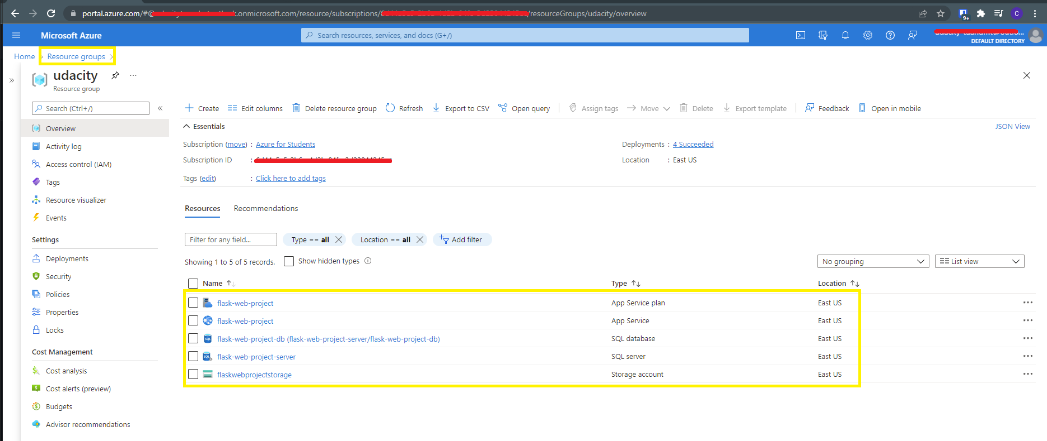

## Storage

### Part 1:

CRITERIA

* Create and add article data to a SQL Server in Azure.

MEETS SPECIFICATIONS

* A SQL Server is created in Azure and is capable of storing the necessary article data (title, author, body).
* Provide a screenshot from your SQL database within Azure, showing that both the posts and users tables have been created. Alternatively, if the site is still live, provide the URL for the site.

HOW TO DO IT

* Create SQL Database
* Create SQL Database Server first and then create database on that server.
* Tab Basics/Configure select Service tier as **Basic**.
* Tab Networking. To make it easy to connect and complete the project, we will publicize this server.
  + Connectivity method: **Public endpoint.**
  + Allow Azure services and resources to access this server: **Yes**.
  + Add current client IP address: **Yes**.
* After creating SQL Database, you can use SSMS to try to connect first, to make sure connect successfully before deploy web (Check connection: SQL Database/ Properties).
* Import data 2 tables “users” and “posts” in folder **sql_scripts** into database. Can import on Portal (SQL Database / Query editor) to import or import from local.
* After creating SQL Database, you can use SSMS to try to connect first. Avoid that you don't know if there is a problem when you do Web deploy. (See connection: SQL Database/ Properties)
* The screenshot must show that the data has been successfully imported.

Additional Resources:

* [Azure Databases](https://azure.microsoft.com/en-in/product-categories/databases/)

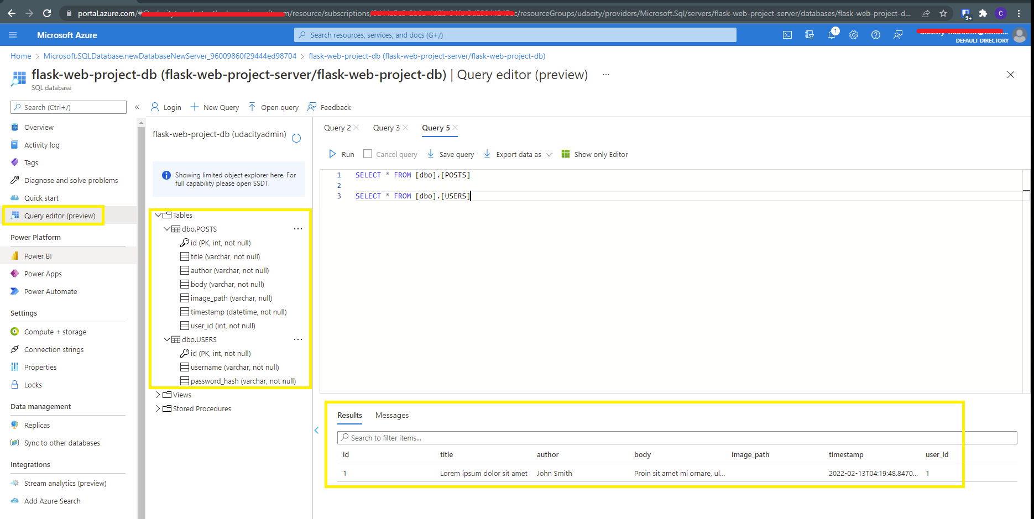

### Part 2:

CRITERIA

* Create and upload images to a Storage Account.

MEETS SPECIFICATIONS

* A Storage Account is created in Azure and is capable of storing the necessary image data for an article.
* Provide a screenshot from your Storage Account within Azure, with the blob storage endpoint URL visible (can be seen in Settings -> Properties). Alternatively, if the site is still live, provide the URL for the CMS site to show images are able to be stored and viewed.

HOW TO DO IT

* Create Storage Account
* Screenshots can be done 2 ways.
* Capture endpoints of Storage Account.
* Or the URL of Web that we are about to deploy displays images from Blob.
* **Note:** This is not a connection to configure when deploying Web

Additional Resources:

* [Azure Storage](https://docs.microsoft.com/en-us/azure/storage/common/storage-account-overview)

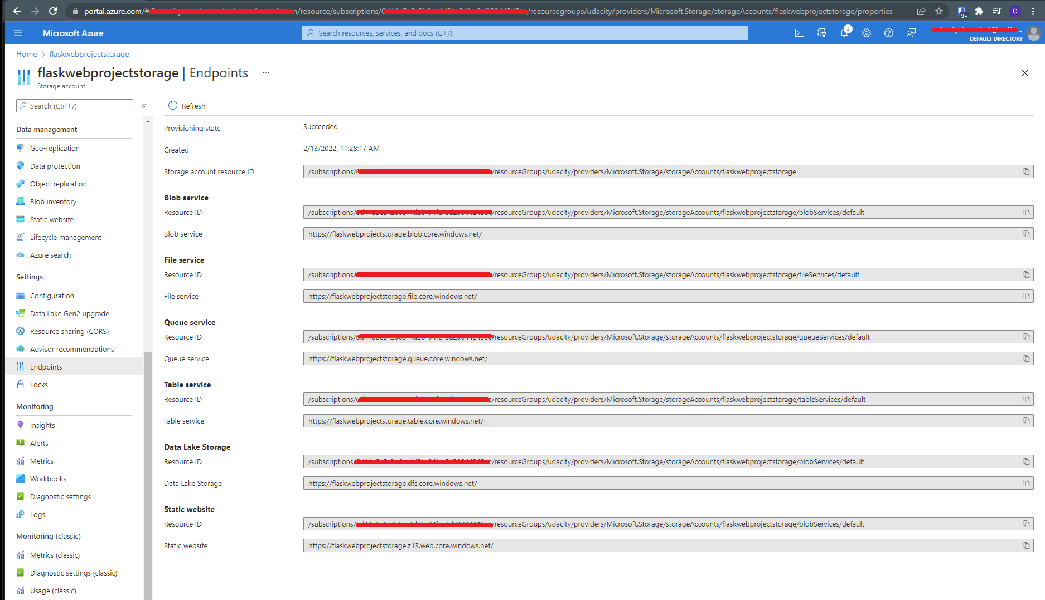

## Resource Justification

### Part 1:

CRITERIA

* Analyze, choose, and justify the appropriate resource option for deploying the app.

MEETS SPECIFICATIONS

* In the provided writeup.md file, for **both** a VM or App Service solution for the CMS app:
  + Analyze costs, scalability, availability, and workflow
  + Choose the appropriate solution (VM or App Service) for deploying the app
  + Justify your choice
* This does not need to be substantially long, but should include information on all four analysis points for each option, your choice, and at least 2-3 sentences on why you choose that option

HOW TO DO IT

* **Key Note**: You need to consider cost analysis, scalability-like features in more detail!!
* **Hint** : You can create a table to display differences b/w both of the services !!  
  You can explain like how a particular **VM**in a tier can cost and similarly **Azure App Service** in tier can cost. So, like you can compare the scenarios.
* For some helpful analysis between these options, check out this => [**post**](https://cloudacademy.com/blog/microsoft-azure-app-service-virtual-machines/).

*FURTHER READING*

* [Azure Pricing](https://azure.microsoft.com/en-in/pricing/calculator/)
* [Scalability](https://docs.microsoft.com/en-us/azure/architecture/guide/technology-choices/compute-decision-tree#scalability)
* [Availability](https://azure.microsoft.com/en-in/support/legal/sla/virtual-machines/v1_9/)
* [App Service pricing](https://azure.microsoft.com/en-us/pricing/details/app-service/linux/)

### Part 2:

CRITERIA

* Assess app changes that would change your decision.

MEETS SPECIFICATIONS

* In the provided writeup.md file, detail how the app and any other needs would have to change for you to change your decision in the last section.
* This should be at least 2-3 sentences, but feel free to add as much detail as you feel necessary.

HOW TO DO IT

* [Link](https://docs.microsoft.com/en-us/azure/cost-management-billing/) you can take reference from this and see cost estimation!
* Here is some helpful cost analysis: [Azure Cost Management + Billing documentation](https://docs.microsoft.com/en-us/azure/cost-management-billing/)

## Deployment

### Part 1:

CRITERIA

* The Python web app is deployed to Azure.

MEETS SPECIFICATIONS

* The Python web app has been deployed to Azure using the chosen resource in the previous section.
* As evidence, provide a screenshot of the Python application running from a browser (this can be part of the screenshot in the next section). **The screenshot should include the URL and the black header that states “Article CMS”.** Alternatively, you can provide a link to the deployed app, if it is still live.

HOW TO DO IT

* Recommended to use Visual Studio Code. Because it has an extension that supports deploying to Azure (including all the projects in this course).
* Should deploy locally to test before deploying to Azure.
* After deploying, you can find the Stream Logs section on Azure to see the logs, or VS Code also supports it

**Note**:

* Version of local Python and App Service Python must be the same
* Versions of libraries in the project (requirements.txt) may need updating.
* The *pyodbc* driver version must match the Azure Database version.
* Should keep App Service after submitting the project for reviewers to see.

### Part 2:

CRITERIA

* The Python web app is able to connect to storage.

MEETS SPECIFICATIONS

* The Python web app is able to connect to the related storage solutions.
* As evidence, provide a screenshot of the Python application running from a browser. **The screenshot should include the URL and at least one article containing title, author, body, and an image.** Alternatively, you can provide a link to the deployed app, if it is still live.

HOW TO DO IT

* Check the connections in *config.py*
* Make sure that Account Storage is public.
* [Connecting Your App to Storage](https://learn.udacity.com/nanodegrees/nd081/parts/cd1756/lessons/1d8ea262-7b5a-4bfd-925f-5b917b87bf2f/concepts/48c1752b-1c0d-4581-b4ab-3d7944c35398)
* Here are some tips and tricks related to [Azure Web App](https://www.michaelcrump.net/azure-tips-and-tricks23/).

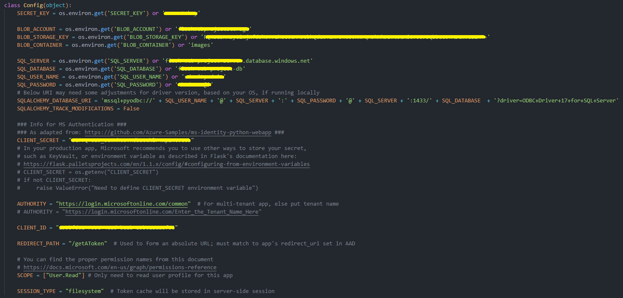

## Security & Monitoring

### Part 1:

CRITERIA

* Add a functioning “Sign in with Microsoft” option to the app.

MEETS SPECIFICATIONS

* The Python web app has an additional, operational option to sign in with Microsoft.
* As evidence, provide a screenshot of the redirect URIs configured within the App Registration page in Azure. Alternatively, you can provide a link to the deployed app, if it is still live.
* Additionally, your code in views.py should appropriately implement the Microsoft sign-in button using the msal library.

HOW TO DO IT

* Guideline in here: [OAuth2 with MSAL](https://learn.udacity.com/nanodegrees/nd081/parts/cd1756/lessons/40f604b5-154e-4c3d-919e-7665aafff80a/concepts/717dad39-dde7-4ab0-90da-182874c3761f)
  + Avoid confusion between *Client Secret* and *Secret Id*.
* Here is a reference Link on [MSAL](https://github.com/AzureAD/microsoft-authentication-library-for-python).

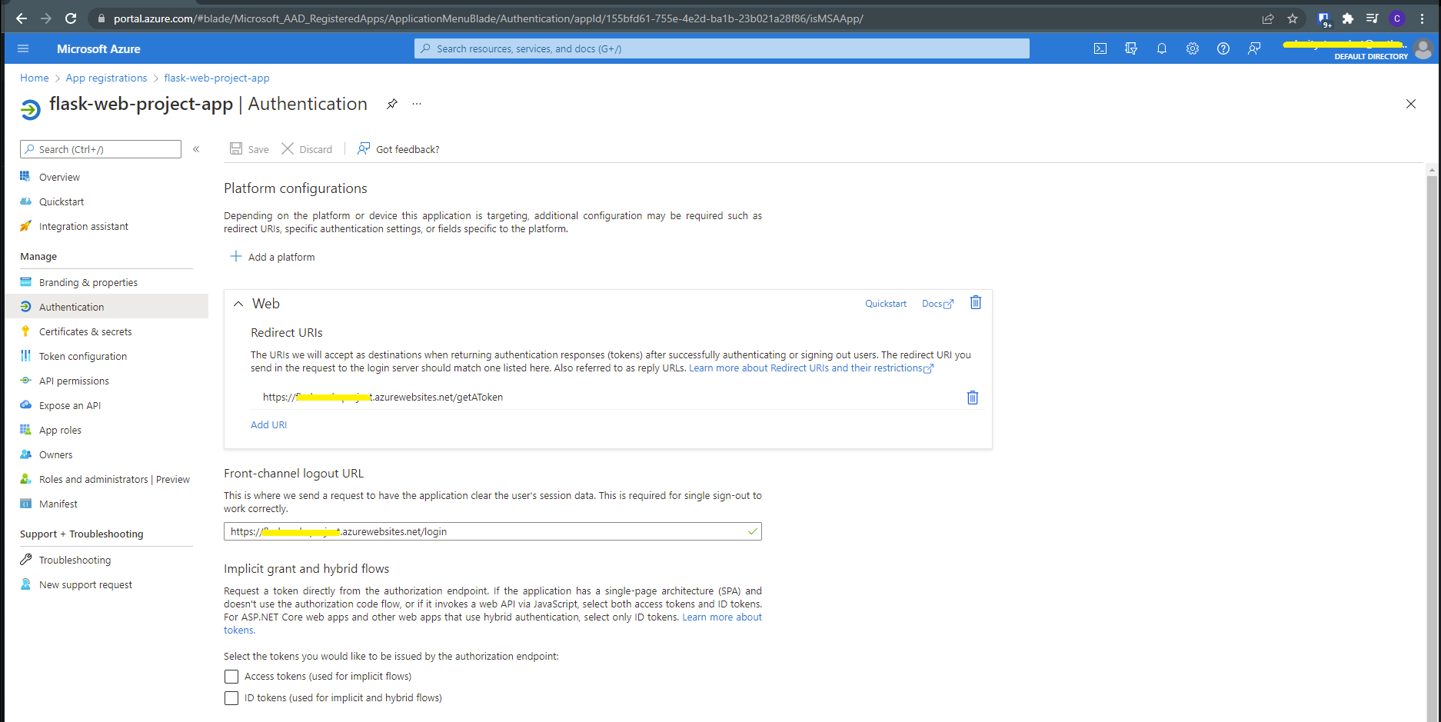

### Part 2:

CRITERIA

* Access attempts to the app are logged.

MEETS SPECIFICATIONS

* Both successful and unsuccessful attempts to access the web app are logged.
* As evidence, provide a screenshot or download the logs from Azure containing at least one successful and one unsuccessful access attempt, and include in your submission files. If otherwise submitting a URL, please include a link to screenshot/logs in the “Submission Details” box on the project submission page.

HOW TO DO IT

* Guideline in here: [Monitoring & Logging](https://learn.udacity.com/nanodegrees/nd081/parts/cd1756/lessons/40f604b5-154e-4c3d-919e-7665aafff80a/concepts/95ca3865-cbc6-4ec0-a3f2-7a8e12f6d31b)

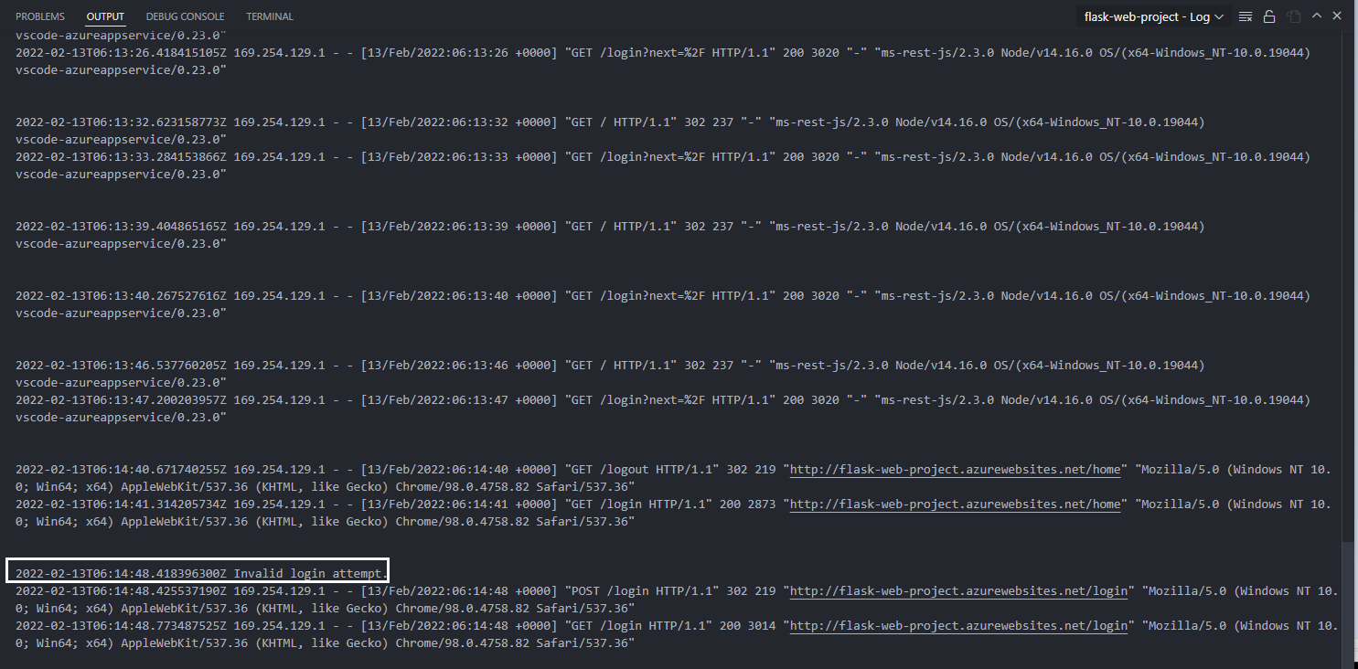

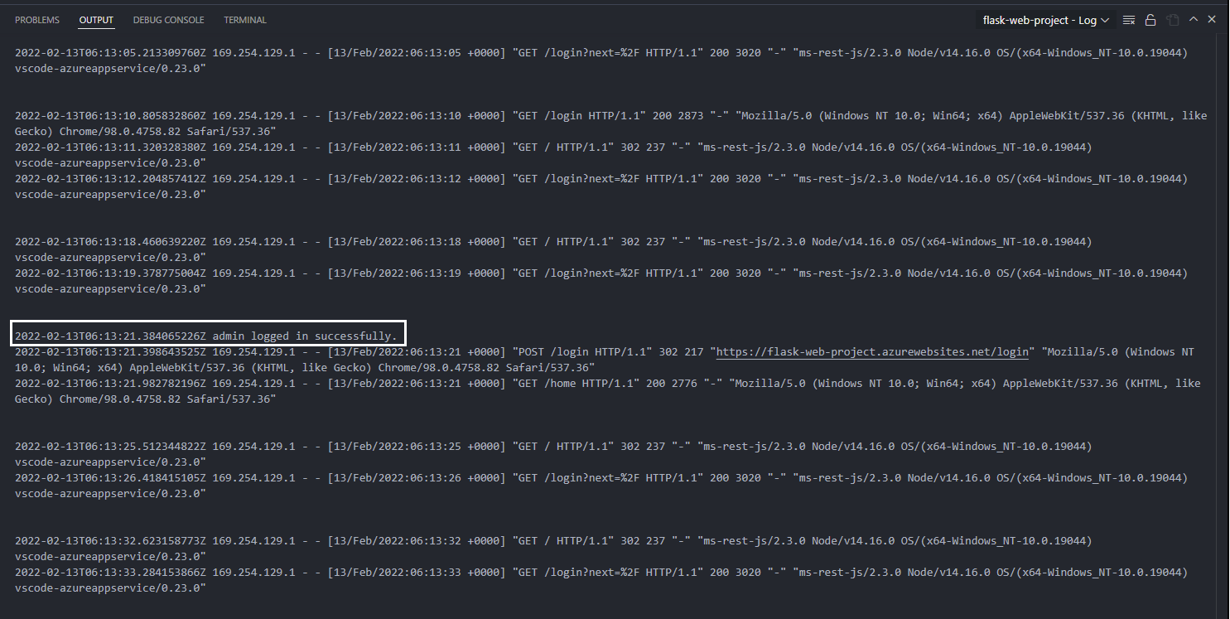

# Project 2: Deploying the Neighborly App with Azure Functions

## Server less Functions

### Part 1:

CRITERIA

* A MongoDB database in Azure CosmosDB service is created and initialized with the sample data provided.

MEETS SPECIFICATIONS

* Students should be able to create a MongoDB database, two collections, and import raw data into the database. The MongoDB database is hosted in Azure CosmosDB.
* To pass this criteria, you can provide a screenshot from the Azure portal showing the database & collections, as well as confirmation that the two pieces of sample data for advertisements (5 documents) and posts (4 documents) were imported correctly.

HOW TO DO IT

* Create a CosmosDB account for MongoDB API: [Create Azure Cosmos DB - Azure Portal (1.7)](https://learn.udacity.com/nanodegrees/nd081/parts/cd1883/lessons/55f013c2-07a2-4546-b9b3-86bede8af413/concepts/87b77295-8908-4512-9117-e5e6cd0aab91)
* Create a MongoDB database:
  + [VS Code](https://learn.udacity.com/nanodegrees/nd081/parts/cd1883/lessons/55f013c2-07a2-4546-b9b3-86bede8af413/concepts/87185883-ecbe-441f-8126-be044a921775)
  + [Azure Portal](https://learn.udacity.com/nanodegrees/nd081/parts/cd1883/lessons/55f013c2-07a2-4546-b9b3-86bede8af413/concepts/ebc33b9d-daad-4dfa-9624-bea44ab5ae46)
* Import Sample Data into MongoDB collection
  + The provided import command may not work in this case, refer to *Additional Resources*
  + You need to provide the information for the command: Your CosmosDB hostname, port, database name, collection name, username - password of your CosmosDB account, file url, options: –jsonArray --writeConcern=”{w:0}”
  + Take a screenshot form the terminal right after importing successfully
  + A **screenshot** from the Azure portal showing the database & collections: There must be at least 2 screenshot showing the two successfully imported collections with their data

Additional Resources:

* + [mongoimport](https://www.mongodb.com/docs/database-tools/mongoimport/)

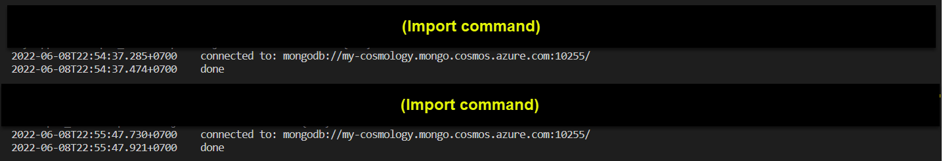

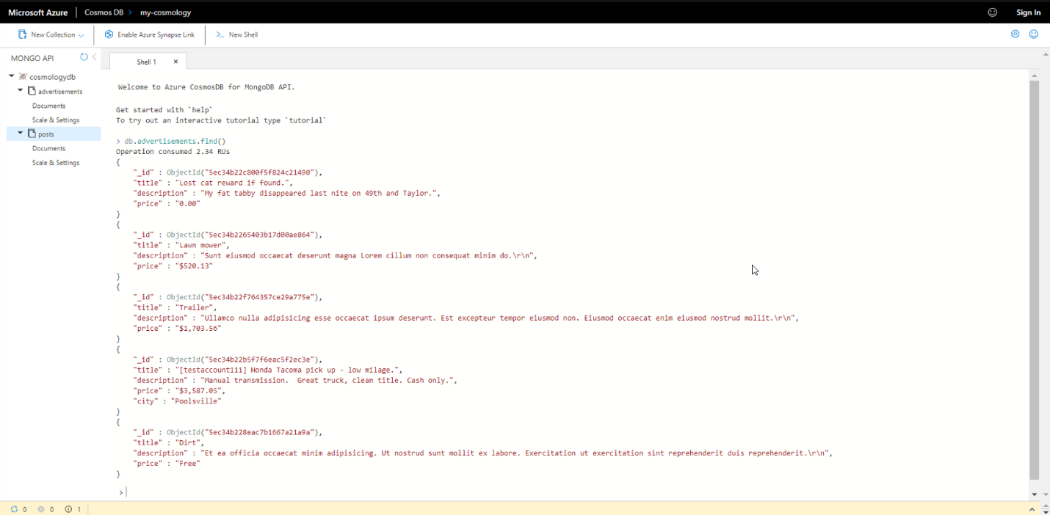

### Part 2 & Part 3:

CRITERIA

* The finished server-side application contains working Azure Functions for HTTP Triggers in Python.

MEETS SPECIFICATIONS

* Students are expected to deploy 7 endpoints: createAdvertisement, updateAdvertisement, getAdvertisement, getAdvertisements, and deleteAdvertisement, getPost, getPosts. There should be 7 urls with the format:

https://<STUDENT-APP-NAME>.azurewebsites.net/api/<endpoint>

* To pass this criteria, show a screenshot, including URL, from the Azure portal where it is shown what endpoints are live.

CRITERIA

* The Azure Functions HTTP Trigger endpoints can connect to MongoDB in Azure CosmosDB service

MEETS SPECIFICATIONS

* To verify that the database is configured, the student should be able to retrieve the connection on each of their API endpoints in the server-API application.
* To pass this criteria, show a screenshot, including URL, of at least the data returned from querying the getAdvertisements endpoint; other endpoints will be checked for reasonableness within the related code files.

HOW TO DO IT

**Update Functions**

* Hook up your connection string into the NeighborlyAPI server folder, by modifying each functions's __init__.py class with your CosmosDb connection string and database name (marked by TODO comment)
* Just skip eventHubTrigger project, we will visit it later
* Demo:
  + [Connect Functions and Database - Part 1 - VS code](https://learn.udacity.com/nanodegrees/nd081/parts/cd1883/lessons/55f013c2-07a2-4546-b9b3-86bede8af413/concepts/fdb67165-116a-4d66-9c27-5e8de4dabfaf)
  + [Connect Functions and Database - Part 2 - VS code](https://learn.udacity.com/nanodegrees/nd081/parts/cd1883/lessons/55f013c2-07a2-4546-b9b3-86bede8af413/concepts/1fe8ac38-828d-4608-9900-3d5f0535113d)
  + [Connect Functions and Database - Part 1 - Azure CLI](https://learn.udacity.com/nanodegrees/nd081/parts/cd1883/lessons/55f013c2-07a2-4546-b9b3-86bede8af413/concepts/bf56c417-012d-4c15-8a84-aa62dfb4b7e3)
  + [Connect Functions and Database - Part 2 - Azure CLI](https://learn.udacity.com/nanodegrees/nd081/parts/cd1883/lessons/55f013c2-07a2-4546-b9b3-86bede8af413/concepts/889a63b4-38e4-4e3c-a420-d0785ffe4b73)

**Deploy**

* Deploy using VS Code's Azure extension:
  + [Create and Deploy a Function - VS Code](https://learn.udacity.com/nanodegrees/nd081/parts/cd1883/lessons/55f013c2-07a2-4546-b9b3-86bede8af413/concepts/d543b9a4-f71c-4341-ac5a-9e33d7c14236)
* Verify that all of them were deployed successfully:
  + You can see the HTTP Triggers are all enabled
  + Test the endpoint with Postman: You should test through at least 3 API and provide their response's screenshot, see: [Testing Your Endpoints with Postman](https://learn.udacity.com/nanodegrees/nd081/parts/cd1883/lessons/55f013c2-07a2-4546-b9b3-86bede8af413/concepts/3298e0ca-b3fb-4192-b7b8-0f9d164dbd21)

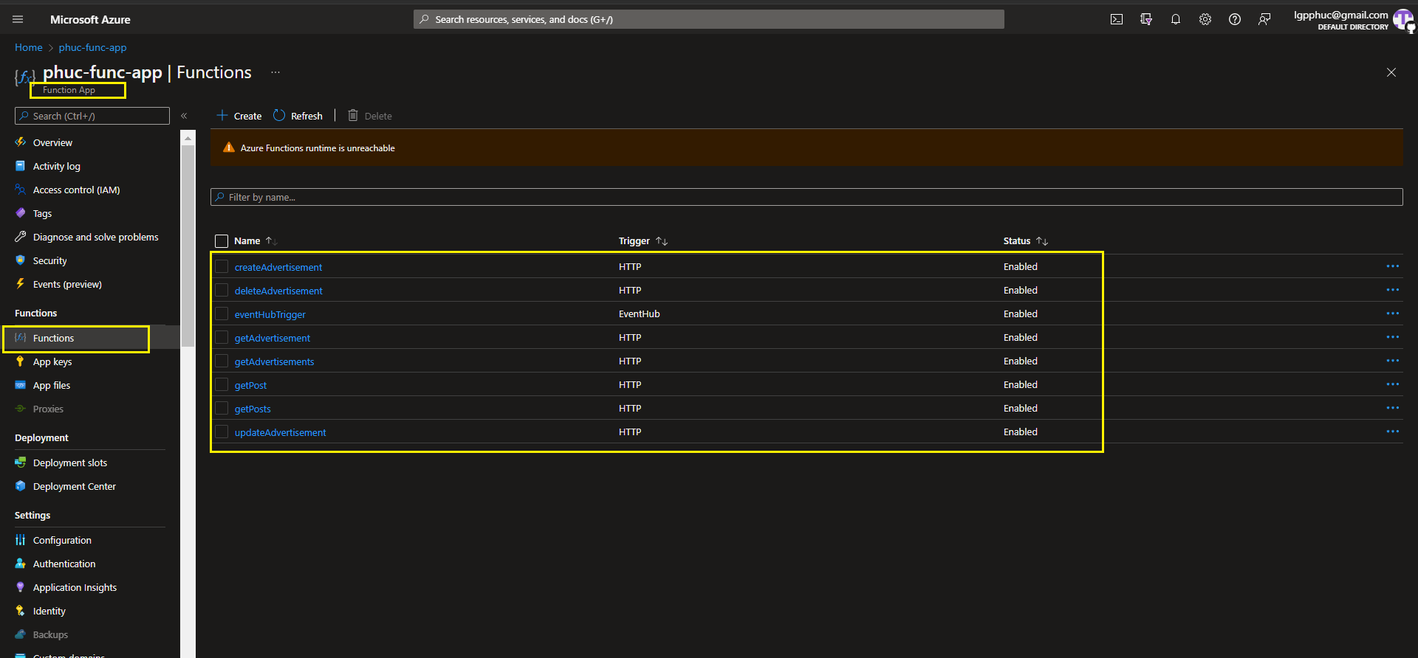

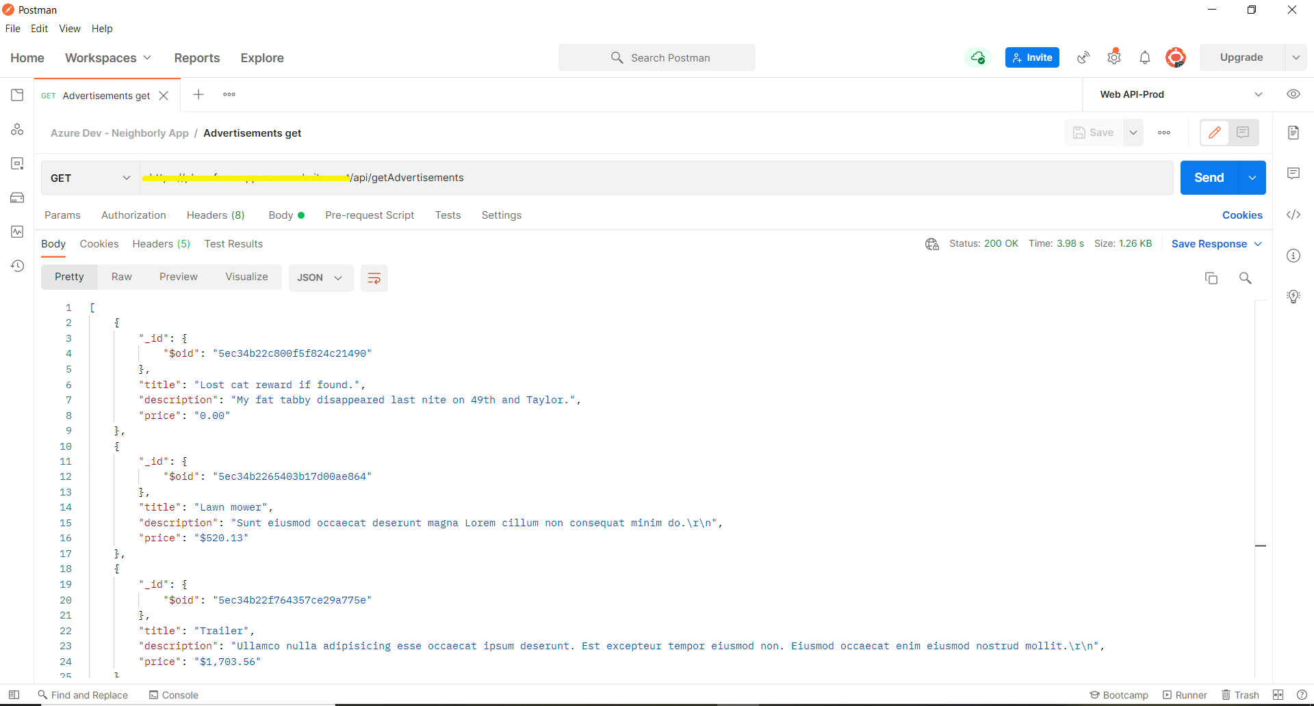

### Part 4:

CRITERIA

* The client-side application in Flask should be able to call the live Functions API endpoints that the students published in previous steps.

MEETS SPECIFICATIONS

* The client-side python Flask application has the routes to obtain services created by server-side Azure Functions endpoints. The student can run the client-side application on localhost:5000 and on the home page, and should be able to view the feed of advertisements and posts.
  + Update the front-end code to appropriately query your published API
  + Provide a screenshot here of the front-end appropriately pulling up posts when you visit localhost. Note that if you have provided a screenshot or URL to a live site with the front-end later on in the assignment, that can also be used as proof here.

HOW TO DO IT

**Modify NeighborlyFrondEnd project:**

* Requirements.txt:
  + azure-functions==1.2.1 (remove)
  + Werkzeug: change from 0.16.1 to <1.0
  + add feedgen==0.9.0
* Change API url from deafult to your function app URL

**Deploy: Refer to Project 1**

* A screenshot of the front-end appropriately pulling up posts when you visit localhost
* Also provide some screenshot of the create/edit ad page

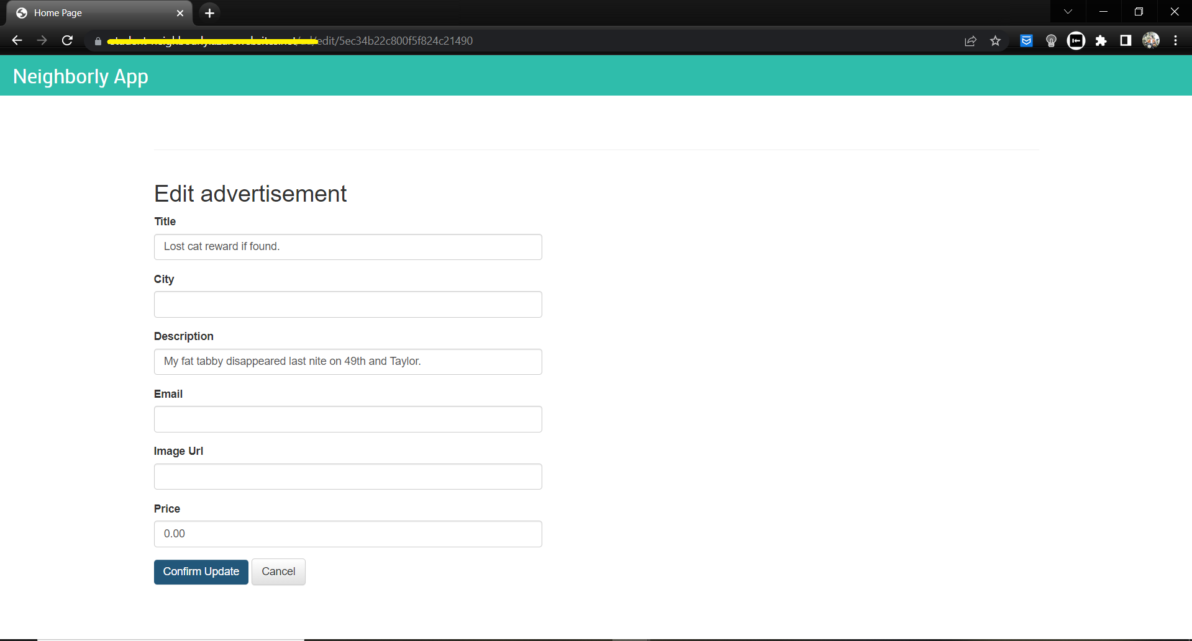

## Logic Apps & Event Hubs

### Part 1:

CRITERIA

* The student demonstrates mastery in using Azure Logic App Designer to create a trigger.

MEETS SPECIFICATIONS

* Students should be able to create a Logic App that watches for an HTTP trigger. When the HTTP request is triggered, the student is sent an email (with Gmail) notification. The student can validate this by a screenshot of their inbox.

HOW TO DO IT

**SendGrid account for sending email**

* ATTENTIONS: you cannot follow the instructions in [Exercise: Logic App Workflow](https://learn.udacity.com/nanodegrees/nd081/parts/cd1883/lessons/800af25f-c158-443c-97a7-14001181afa9/concepts/54103753-c84e-4c6b-8d45-c24ba1ac34aa), because we can no longer register the free service from <https://sendgrid.com/> freely. Subscribe it from your Azure Portal, carefully follow this instructions: [Create a Twilio SendGrid account](https://docs.sendgrid.com/for-developers/partners/microsoft-azure-2021#create-a-twilio-sendgrid-account)
* Also make sure to Activate Sender Authentication, following [Senders](https://docs.sendgrid.com/ui/sending-email/senders), in order to be able to send mail from an exact email address as you wish
* Save the C*onnection name* and *API key*for the next step

**Logic Apps:**

* Follow the demonstration from [Logic Apps](https://learn.udacity.com/nanodegrees/nd081/parts/cd1883/lessons/800af25f-c158-443c-97a7-14001181afa9/concepts/ff43c194-66cb-4aa2-8370-1cd4d9825a90), [Logic Apps Workflow](https://learn.udacity.com/nanodegrees/nd081/parts/cd1883/lessons/800af25f-c158-443c-97a7-14001181afa9/concepts/54103753-c84e-4c6b-8d45-c24ba1ac34aa), but attend:
  + The Plan Type must be **Consumption**
  + Because the requirements are "a Logic App that watches for an HTTP trigger", the first *Steps*must be **"When a HTTP request is received"**, instead of "RSS feed"
  + The "From" field must be the sender email you activate in the previous step
  + The Body can be some message, request headers or body content

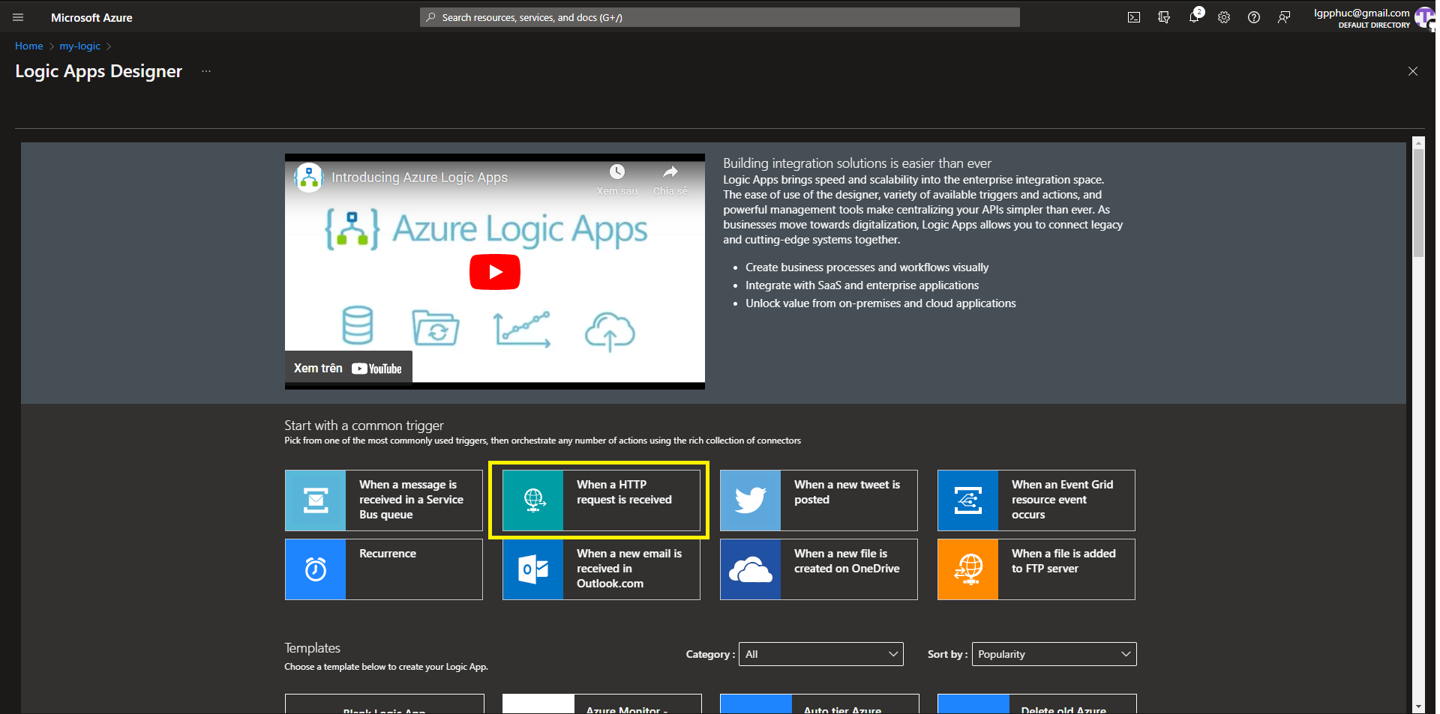

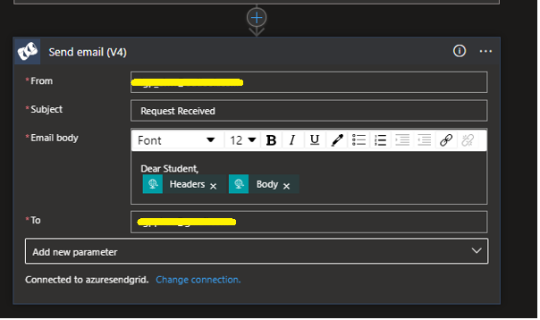

### Part 2:

CRITERIA

* The student should be able to create a custom event grid topic and publish the topic.

MEETS SPECIFICATIONS

* The student should be able create an Event Hubs namespace and an event hub with the command line or through the portal. If successful, the student can obtain the namespace url. Add a screenshot from the portal of this being live.

HOW TO DO IT

* In this requirements, we just need to create a simple Event Hubs namespace and an Event Hub instance, instructions: [Event Hubs](https://learn.microsoft.com/en-us/azure/event-hubs/event-hubs-create#create-an-event-hubs-namespace)

### Part 3:

CRITERIA

* The student should be able to add the connection string of the event hub to the Azure Function.

MEETS SPECIFICATIONS

* The student should be able to use the endpoint connection string from the event hub to the *eventHubTrigger* function in the *function.json* file.

HOW TO DO IT

* Go back to the *eventHubTrigger* project we skipped in the above steps, ready to deploy it along with the other API project, modify its *function.json* file:
  + type: *eventHubTrigger* (not *eventGridTrigger*)
  + eventHubName: the name of your Event Hub namespace
  + connection: the connection string of your Event Hub namespace

## Deploying Your Application

### Part 1:

CRITERIA

* The student should be able to deploy their Neighborly web application on Azure App Service.

MEETS SPECIFICATIONS

* The student should be able to use the live url from Azure App Service in their browser. The URL should be accessible to all users on the World Wide Web, or a screenshot should be provided, including the URL, of the live site.

HOW TO DO IT

* Provide the **live url** from Azure App Service (which should be accessible to all users on the World Wide Web) in a text file, or a **screenshot** should be provided, including the URL, of the previously live site.
* If you completed the Client-side Application deployment step above, you done this requirement

### Part 2:

CRITERIA

* The student should be able to containerize their Flask application with *Dockerfile*.

MEETS SPECIFICATIONS

* The student can run docker build and can import their *Dockerfile* in the Azure Container Registry.
* Provide a screenshot of the *Dockerfile* from Azure Container Registry as evidence.

HOW TO DO IT

* Containerize (*Dockerize*) your local Function and create an Azure Container Registry (ACR) repository. Push the Docker image from local to the ACR repository.
  + Follow: [Containerize and Create Azure Container Registry - CLI](https://learn.udacity.com/nanodegrees/nd081/parts/cd1883/lessons/bd7c7c81-f441-416c-aae6-8518ebe4c56b/concepts/4e210516-3a9f-41cd-bf9e-6028aff2f2a3)
  + The required *Dockerfile* will also be created in this step
  + Just carefully run each commands and watch its result

### Part 3:

CRITERIA

* The code demonstrates an automated pipeline to spin Kubernetes services in Azure.

MEETS SPECIFICATIONS

* The student should be able to create a cluster with the one node.
* Provide a screenshot of confirmation from the terminal, or from within Azure, as evidence.

HOW TO DO IT

**Kubernetes cluster:**[**Instructions**](https://learn.udacity.com/nanodegrees/nd081/parts/cd1883/lessons/bd7c7c81-f441-416c-aae6-8518ebe4c56b/concepts/48537c0c-f61e-4515-a408-d99f9263edf4)

* Create, take a screenshot of your terminal right after creating successfully, try to capture all of the response result
* Store the cluster credentials in the local .kube/config file.
* Verify your connection to it with kubectl get nodes.

**Deploy the function app to Kubernetes**

* [Exercise: Containerize and Deploy to AKS - CLI - Part I](https://learn.udacity.com/nanodegrees/nd081/parts/cd1883/lessons/bd7c7c81-f441-416c-aae6-8518ebe4c56b/concepts/451756c7-6e85-41b8-afaa-56bdab2c1e8f)
* [Exercise: Containerize and Deploy to AKS - CLI - Part II](https://learn.udacity.com/nanodegrees/nd081/parts/cd1883/lessons/bd7c7c81-f441-416c-aae6-8518ebe4c56b/concepts/160a72e3-0114-40ce-a9b9-d8ec4e62ad2e)
* Check your deployment with kubectl config get-contexts

Additional Resources:

* [AZ AKS](https://learn.microsoft.com/en-us/cli/azure/aks?view=azure-cli-latest#az-aks-get-credentials&WT.mc_id=udacity_learn-wwl)

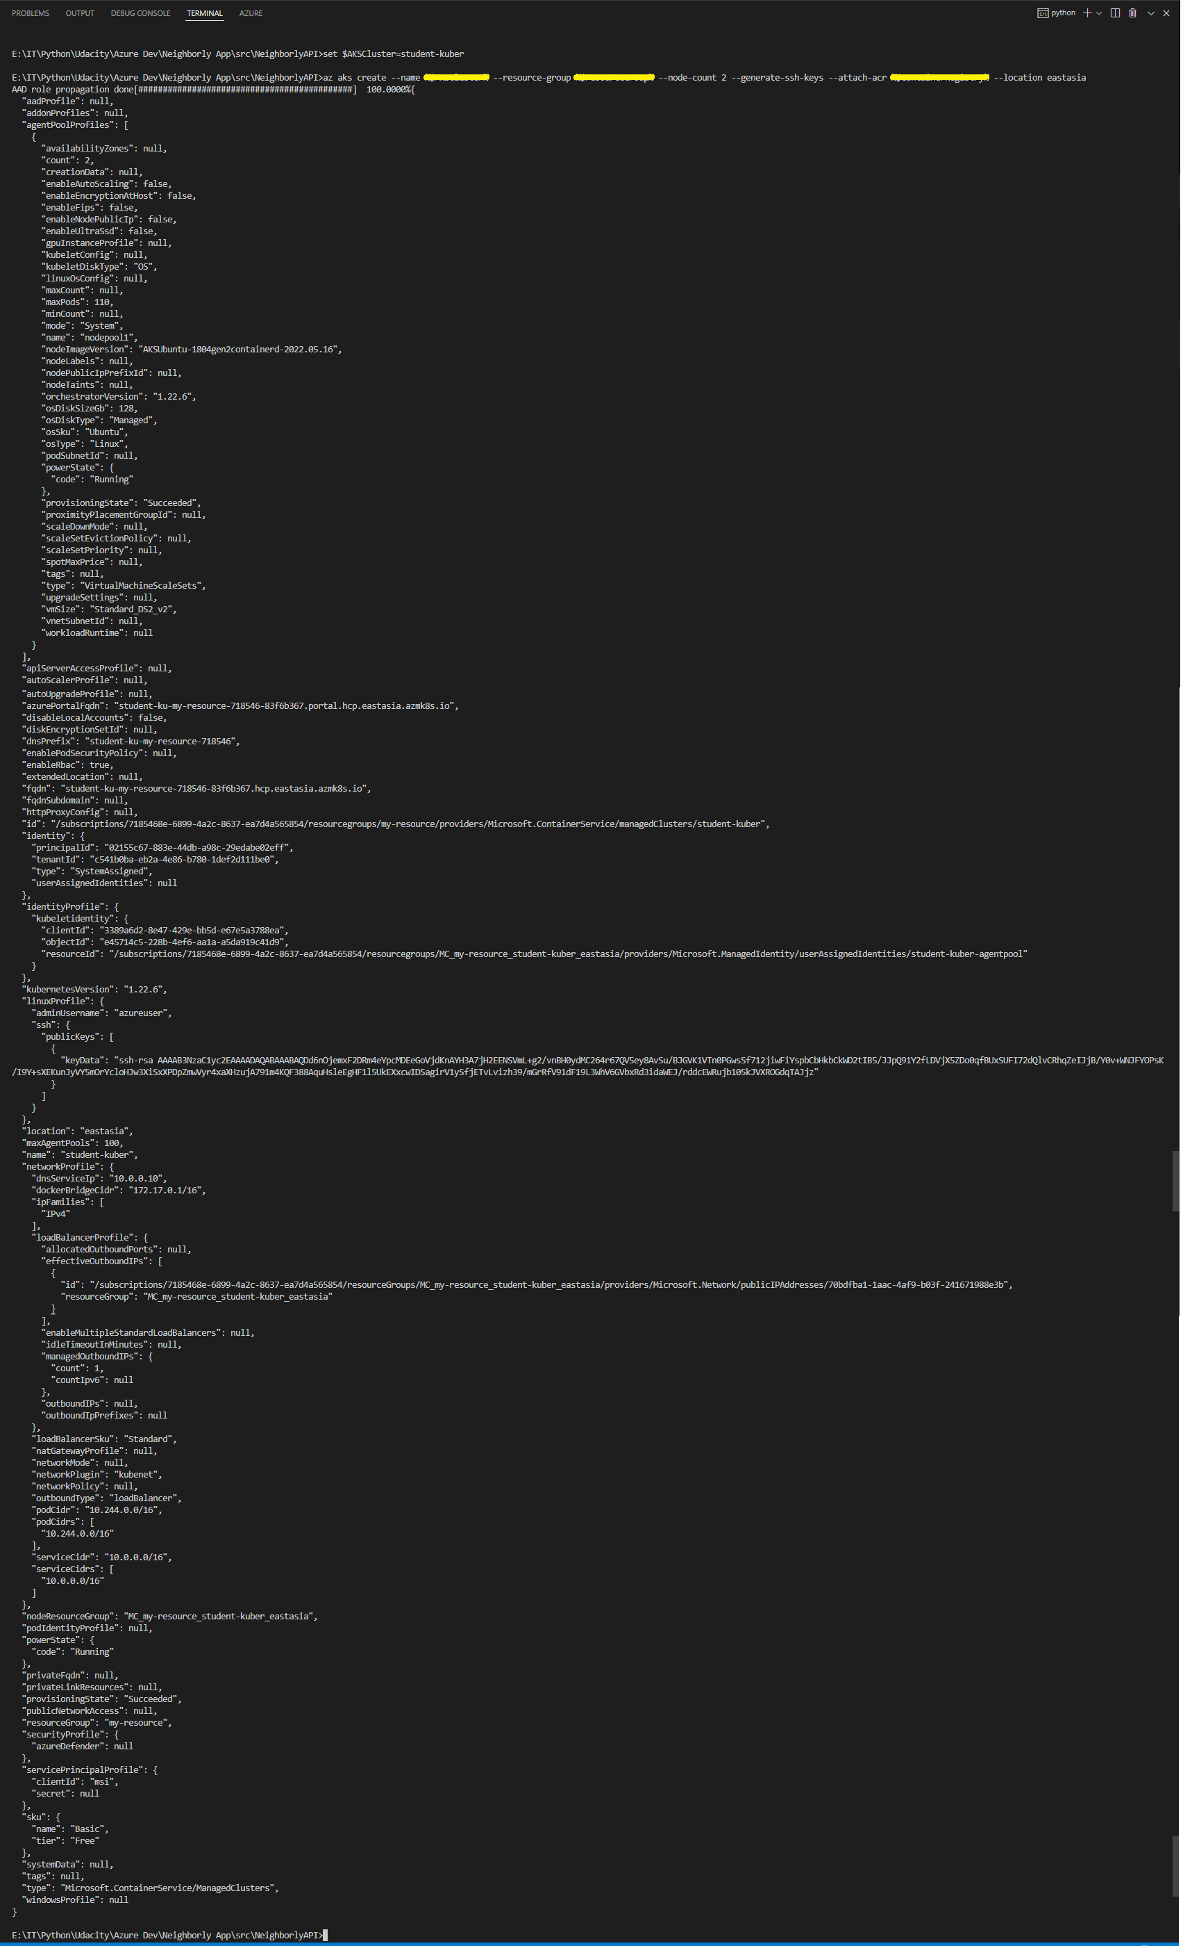

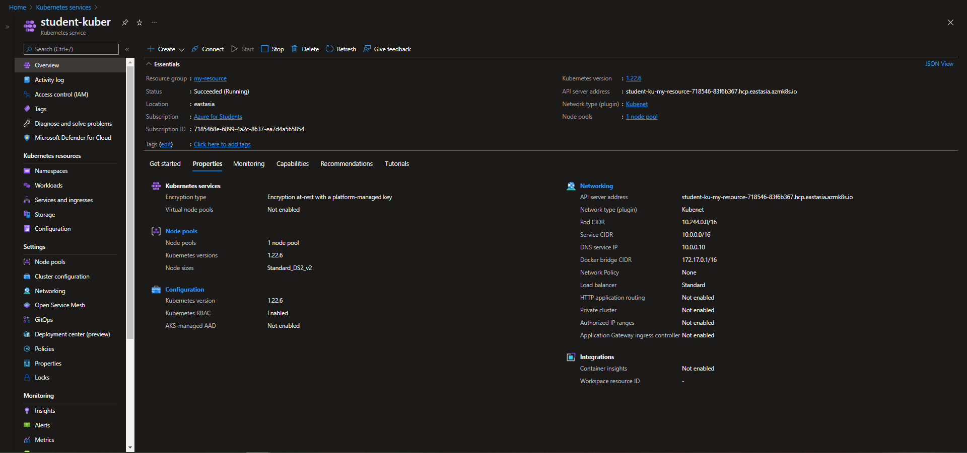

# Project 3: Migrate App to Azure

## Migrate Web Applications

### Part 1:

CRITERIA

* Create an Azure App resource in a free tier app service plan

MEETS SPECIFICATIONS

* Student provides a screenshot of the Azure resource showing the app service plan

HOW TO DO IT

* Create app service and app service plan

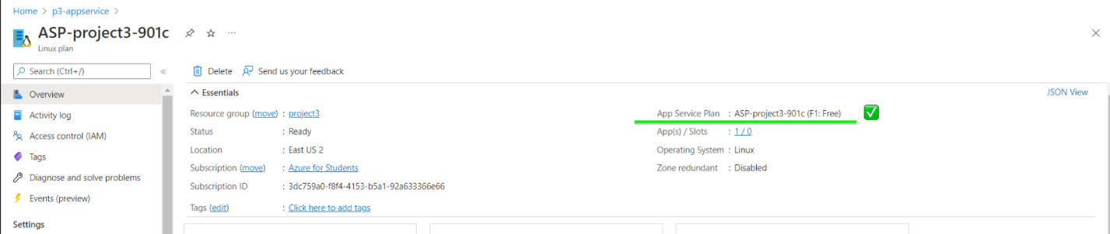

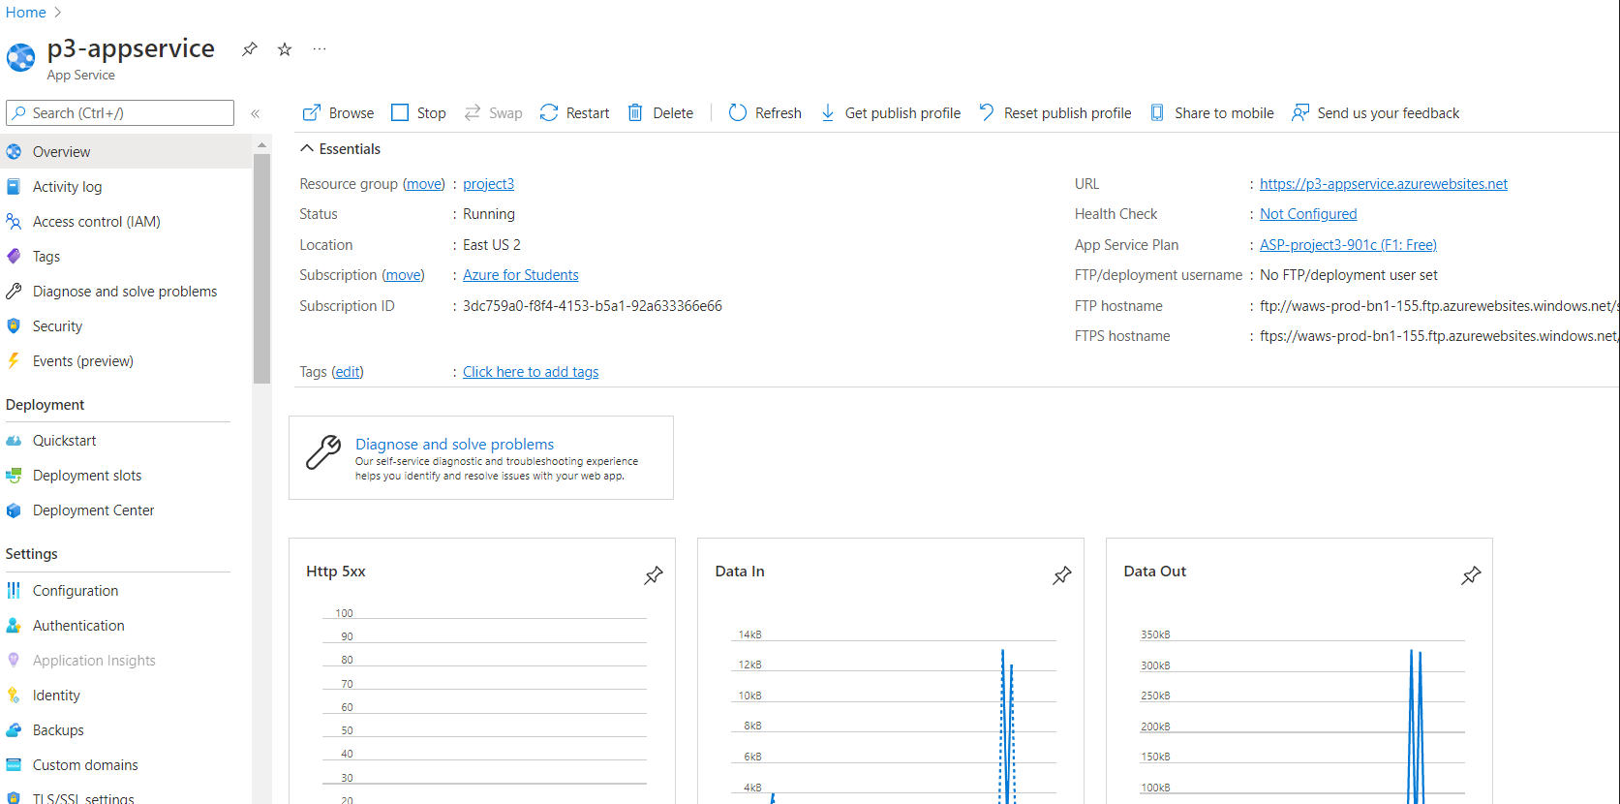

Additional Resources:

* [App Plan Tiers](https://samcogan.com/what-is-an-azure-app-service-plan-and-what-does-it-do/)

### Part 2:

CRITERIA

* Web App code deployed in Azure

MEETS SPECIFICATIONS

* Student provides a screenshot of the application successfully running with the URL in this format **https://\***.azurewebsites.net**. The screenshot should be full screen showing the URL and application running.

HOW TO DO IT

* Here is an additional [Link](https://docs.microsoft.com/en-us/azure/app-service/quickstart-python?tabs=bash&pivots=python-framework-flask) on how to deploy flask apps.

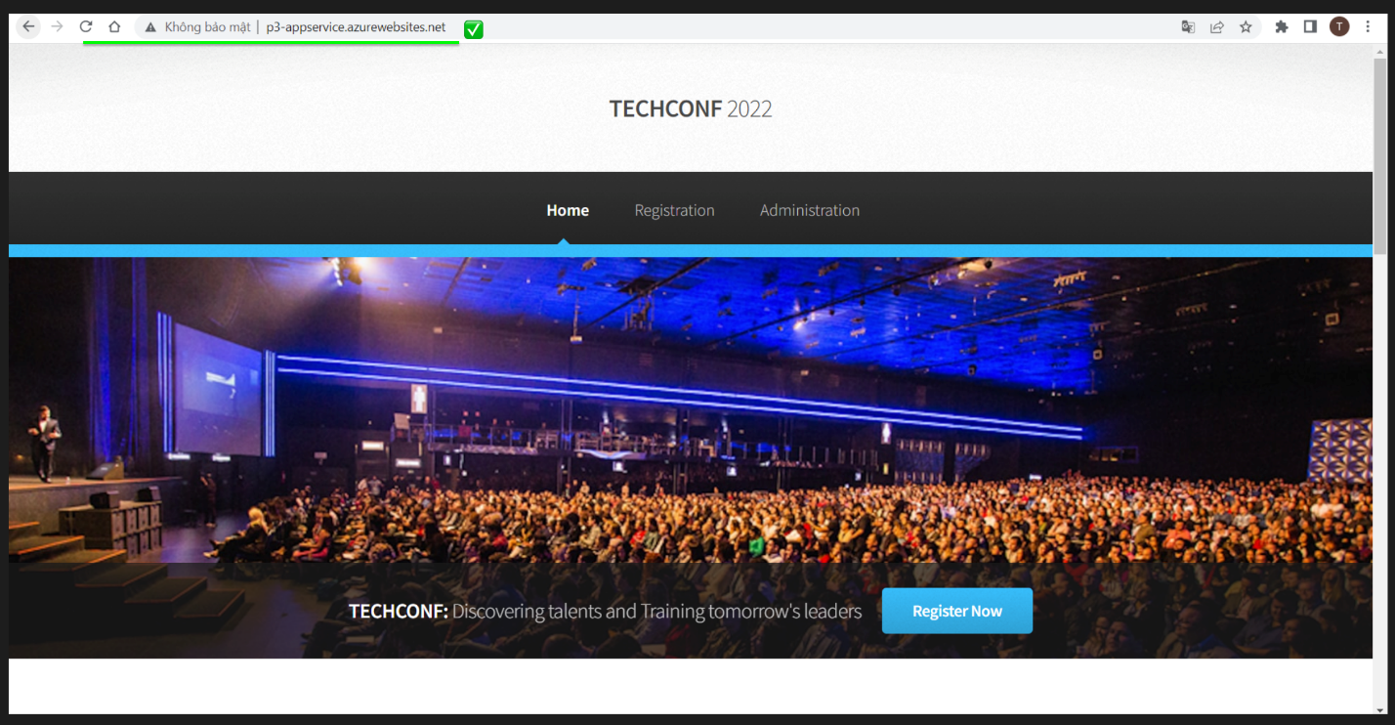

## Migrate Database

### Part 1:

CRITERIA

* Create an Azure Postgres database in Azure

MEETS SPECIFICATIONS

* Student provides a screenshot of the Azure Postgres database resource created in Azure showing the database name, version, server name

HOW TO DO IT

* Here is an additional [**Link**](https://azure.microsoft.com/en-in/product-categories/databases/) on the type of Azure Databases.

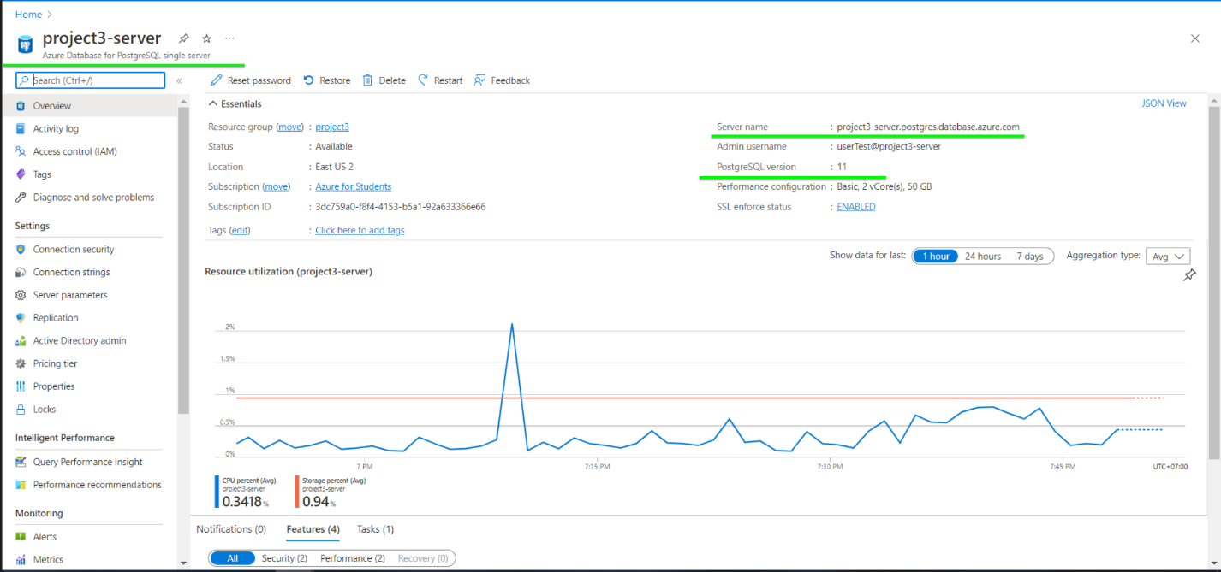

*FURTHER READING*

* [Azure Database for PostgreSQL documentation](https://docs.microsoft.com/en-us/azure/postgresql/)
* [Performance best practices for using Azure Database for PostgreSQL](https://azure.microsoft.com/en-in/blog/performance-best-practices-for-using-azure-database-for-postgresql/)
* [Optimize performance using Azure Database for PostgreSQL Recommendations](https://azure.microsoft.com/en-in/blog/optimize-performance-using-azure-database-for-postgresql-recommendations/)

### Part 2:

CRITERIA

* Restore database backup to Azure Postgres database

MEETS SPECIFICATIONS

* Student provides a screenshot of the web app successfully loading the list of attendees and notifications from the deployed website

HOW TO DO IT

* Screenshot showing web app successfully loading list of attendees

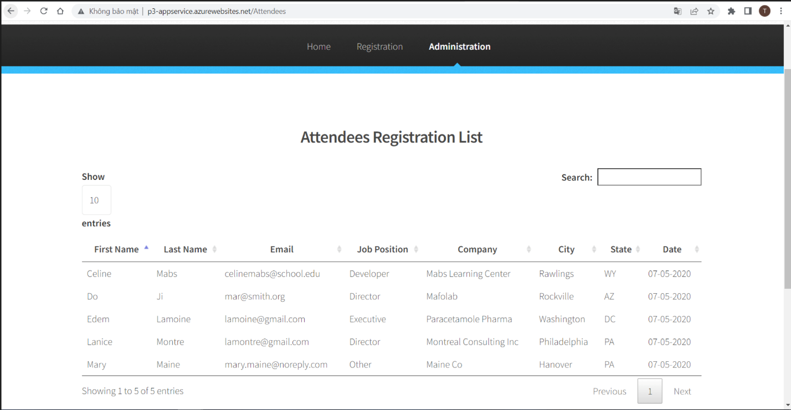

* Screenshot showing web app successfully loading list of notifications

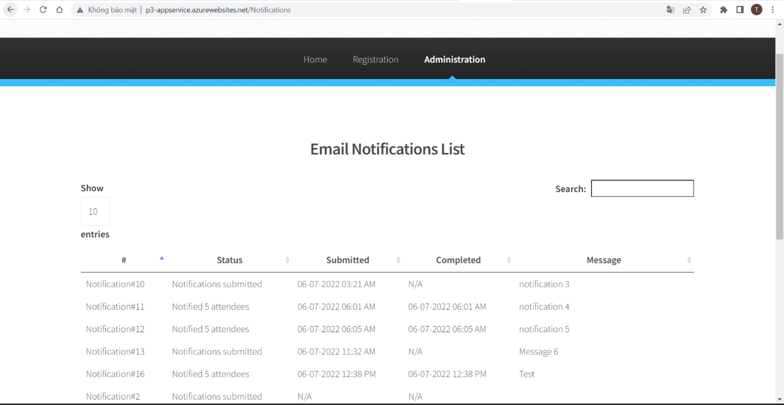

## Migrate Background Process

### Part 1:

CRITERIA

* Create an Azure Function resource for the migration

MEETS SPECIFICATIONS

* Student provides a screenshot of the Azure Function app running in Azure showing the function name and the function app plan

HOW TO DO IT

* Screenshot of the Azure Function App running in Azure showing the function name and the function app plan

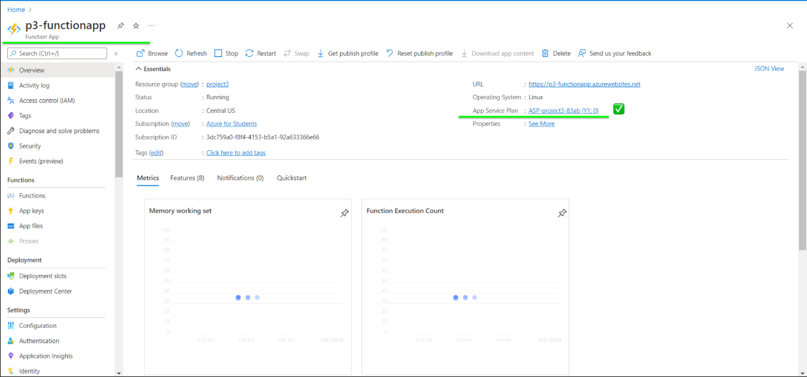

*FURTHER READING*

* [Create Azure Function in the Azure portal](https://docs.microsoft.com/en-us/azure/azure-functions/functions-create-function-app-portal)
* [Azure Functions documentation](https://docs.microsoft.com/en-in/azure/azure-functions/)
* [Best practices for performance and reliability of Azure Functions](https://docs.microsoft.com/en-us/azure/azure-functions/functions-best-practices)

### Part 2:

CRITERIA

* Azure function code implemented, deployed, and triggered

MEETS SPECIFICATIONS

* Student provides screenshots of the following showing functionality of the deployed site:
  1. Submitting a new notification
  2. Notification processed after executing the Azure function

HOW TO DO IT

* Screenshot for submitting a new notification web page

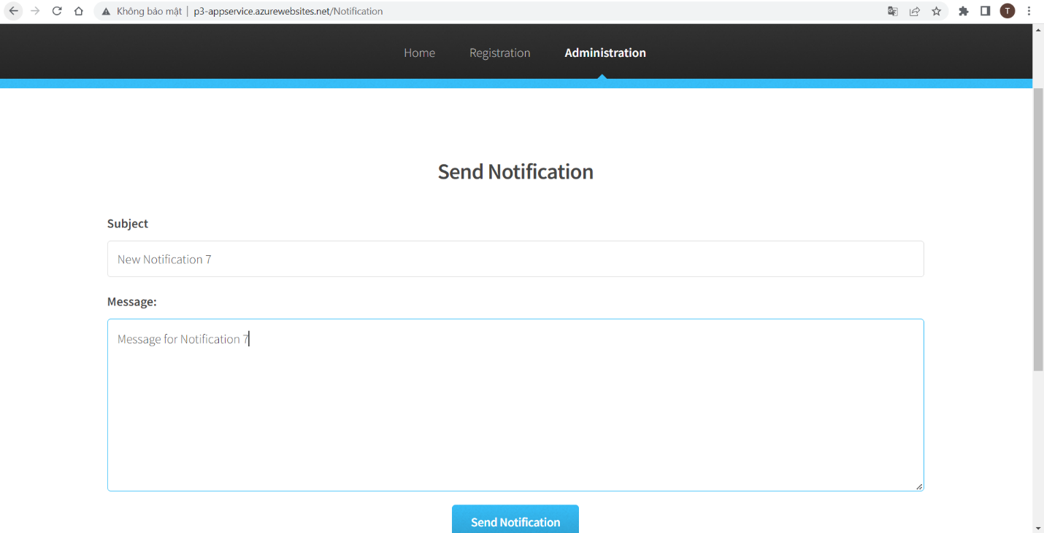

* Notification added to notification list with status Notifications submitted but yet to be processed by ServiceBusQueueTrigger azure function

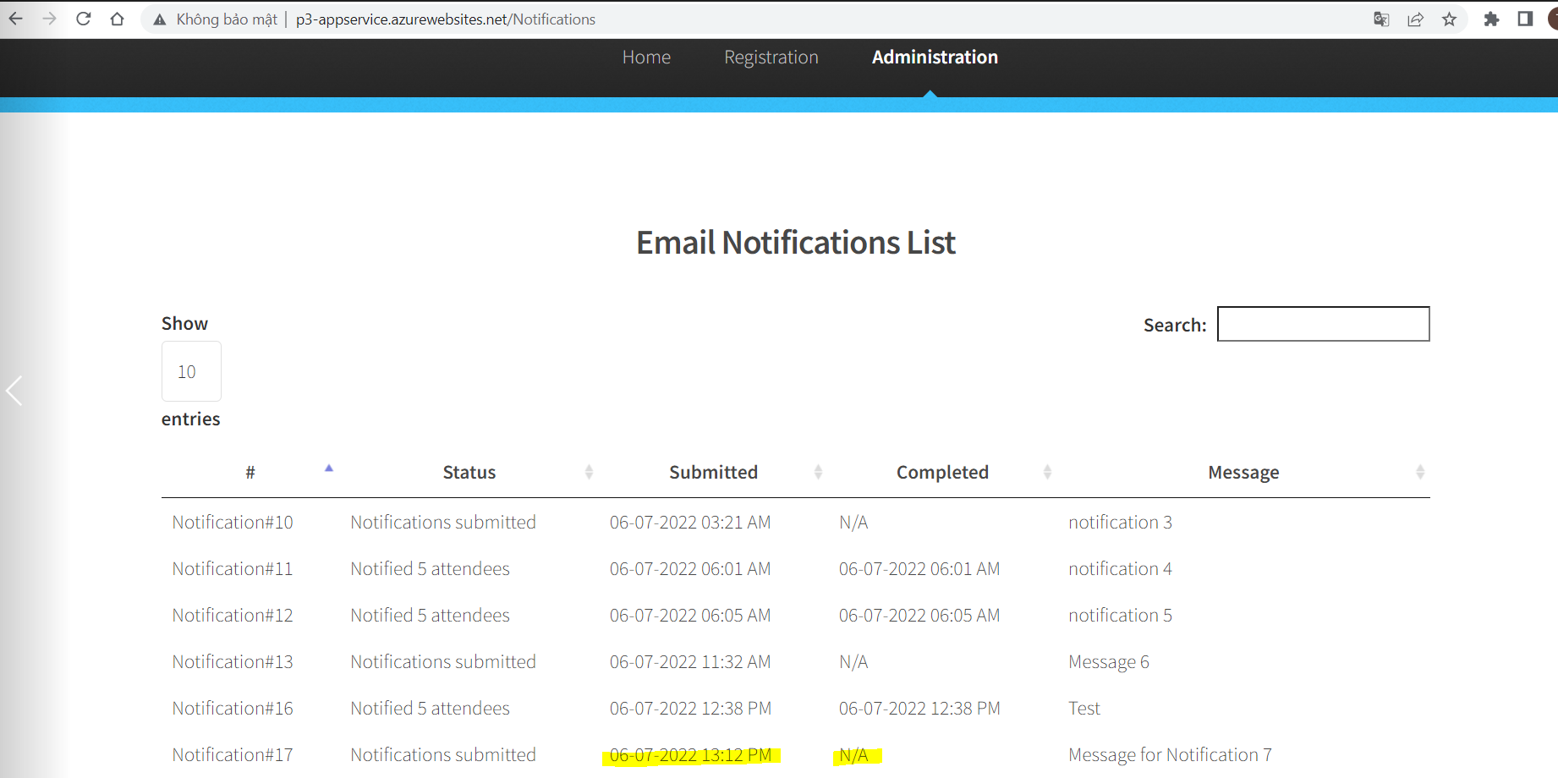

* Notifications is processed by ServiceBusQueueTrigger azure function and contains completed dates as well as total number of attendees notified (status) in the Notifications list

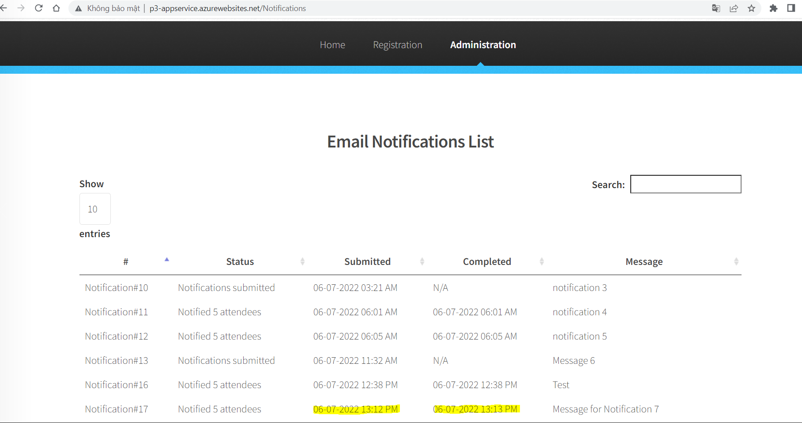

* You are correctly adding message to Service Bus Queue in the web-app
* You have correctly implemented ServiceBusQueueTrigger azure function to process the message from Service Bus Queue

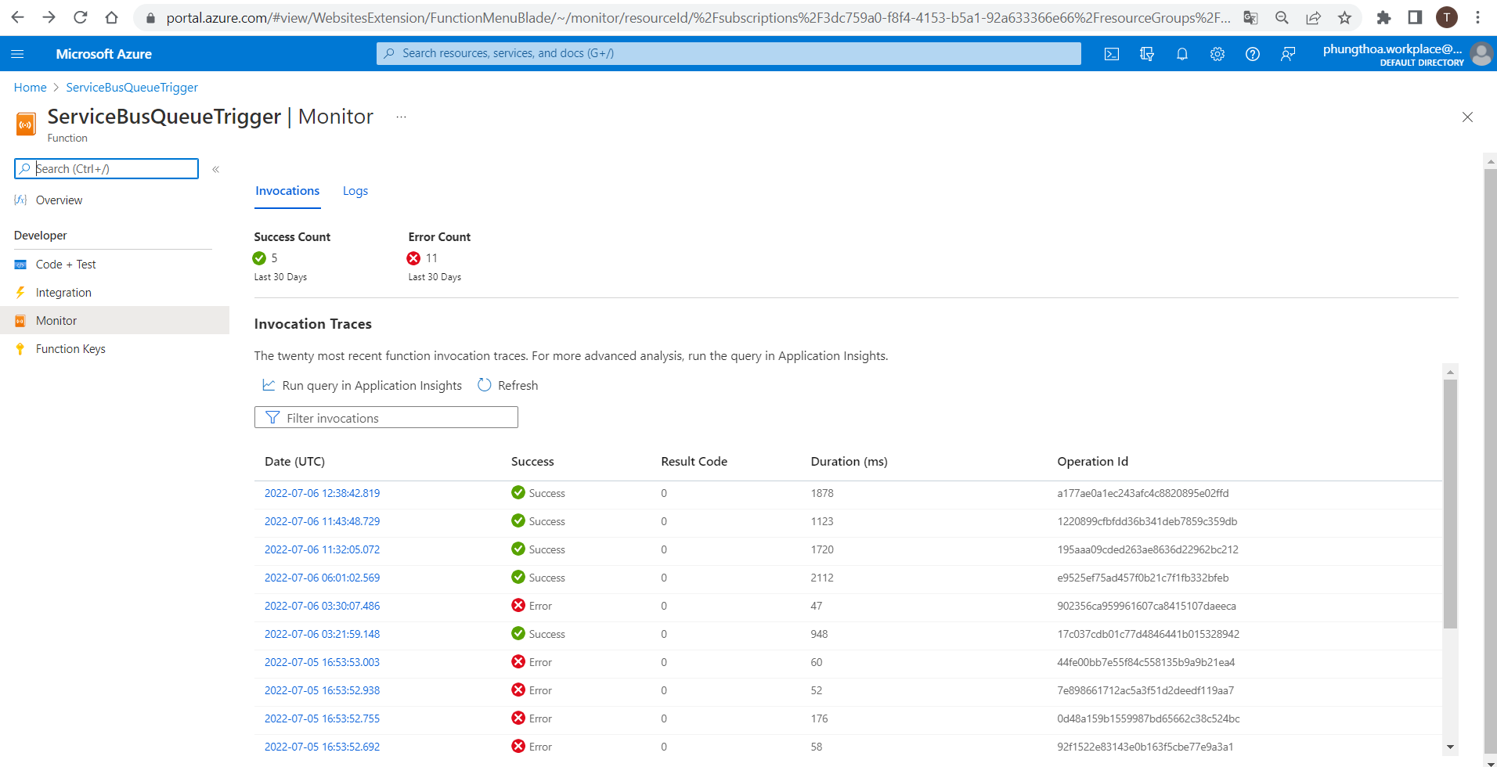

*FURTHER READING*

* [Send messages to and receive messages from Azure Service Bus queues](https://docs.microsoft.com/en-us/azure/service-bus-messaging/service-bus-python-how-to-use-queues)

## Predicting Costs

### Part 1:

CRITERIA

* Cost-effective architecture for web app and function

MEETS SPECIFICATIONS

* Student provides a README that includes a short explanation and reasoning of the architecture selected for both the Azure web app and the Azure function in terms of cost-effectiveness

HOW TO DO IT

* I recommend reading this link for advanced information about serverless functionalities.  
  <https://docs.microsoft.com/en-us/azure/architecture/reference-architectures/serverless/web-app>

Example:

**## Architecture Explanation**

After migrate the application web app to an Azure App Service and refactor the notification logic to an Azure Function via a service bus queue message

   - Scalable web application to handle … [you should continuous here]

   - When admin send notification, it won't take long now, … [you should continuous here]

   - Existing architecture optimized for … [you should continuous here]

### Part 2:

CRITERIA

* Predict the monthly cost of each Azure Resource

MEETS SPECIFICATIONS

* Student provides a README that includes a monthly cost analysis of the project detailing each resource’s cost

HOW TO DO IT

* You can use [Azure Pricing Calculator](https://azure.microsoft.com/en-in/pricing/calculator/) to do that.

For Reference:

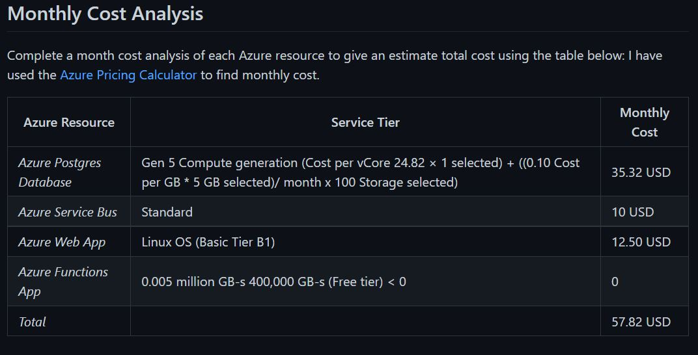

# Project 4: Enhancing Applications

## Set Up of Application Insight

### Part 1:

CRITERIA

* Create appropriate Azure resources to utilize Application Insights and Azure Log Analytics.

MEETS SPECIFICATIONS

* Azure Log Analytics Workspace and Azure Application Insights resources are created.
* As evidence, provide a screenshot of the resource group containing your running resources.

HOW TO DO IT

* Create Azure VMSS resource: run setup-script.sh
* Create Application Insights resource: [Lesson: Setting up Application Insights](https://learn.udacity.com/nanodegrees/nd081/parts/cd1885/lessons/532b4a3a-5761-4538-b0e4-e6eb9a614839/concepts/74597bf9-1367-4274-b79a-0ee0b16c2dc1)

Note: Resources and the resource group should use the same Azure Region

* Add to requirements.txt

Flask==1.1.2

opencensus-ext-azure==1.0.4

opencensus-ext-flask==0.7.3

redis==3.5.3

opencensus==0.7.13

opencensus-ext-logging==0.1.0

opencensus-context==0.1.2

opencensus-ext-requests==0.7.5

appdirs==1.4.4

black==21.7b0

cachetools==4.2.2

certifi==2021.5.30

charset-normalizer==2.0.4

click==8.0.1

colorama==0.4.4

google-api-core==1.31.2

google-auth==1.35.0

googleapis-common-protos==1.53.0

idna==3.2

isort==5.9.3

itsdangerous==2.0.1

Jinja2==3.0.1

MarkupSafe==2.0.1

mypy-extensions==0.4.3

packaging==21.0

pathspec==0.9.0

protobuf==3.17.3

psutil==5.8.0

pyasn1==0.4.8

pyasn1-modules==0.2.8

pyparsing==2.4.7

pytz==2021.1

regex==2021.8.21

requests==2.26.0

rsa==4.7.2

six==1.16.0

tomli==1.2.1

urllib3==1.26.6

Werkzeug==2.0.1

wrapt==1.12.1

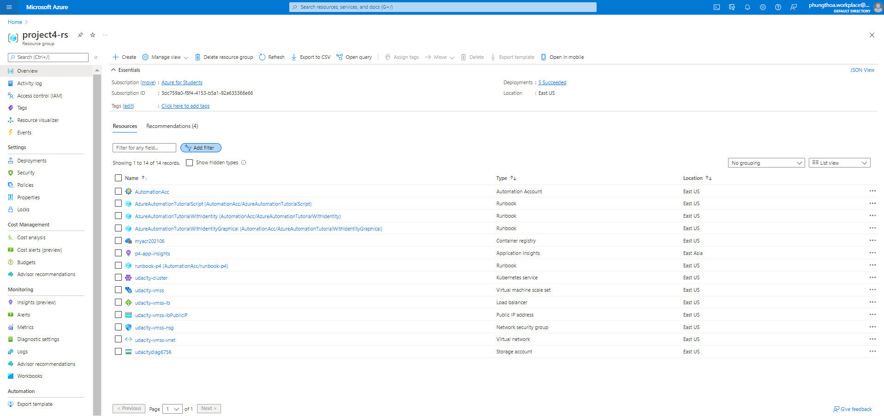  
  
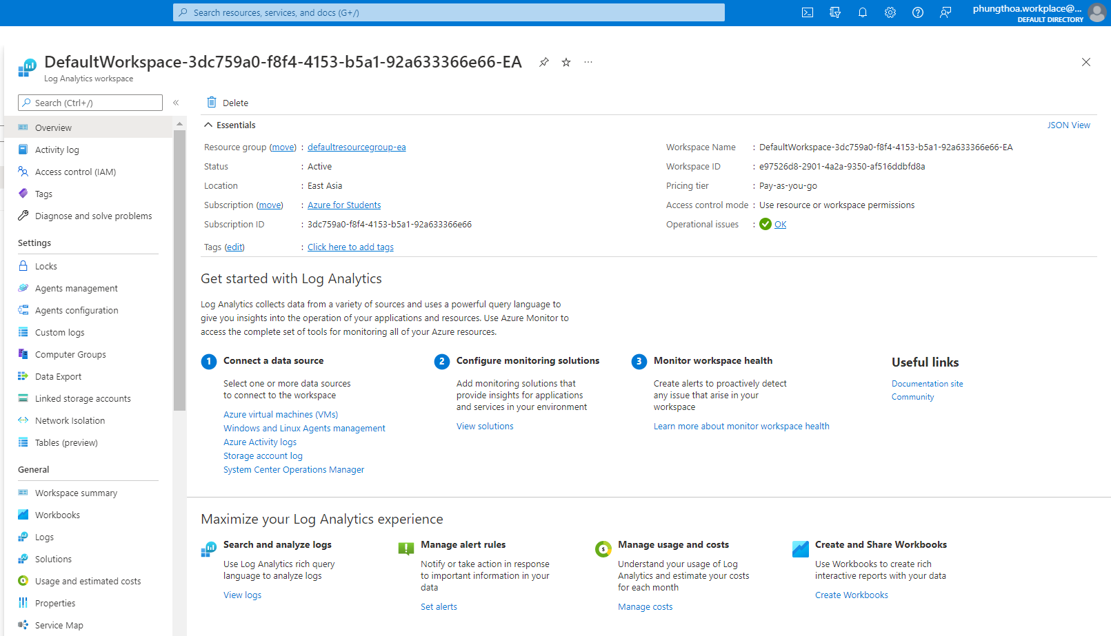  
  
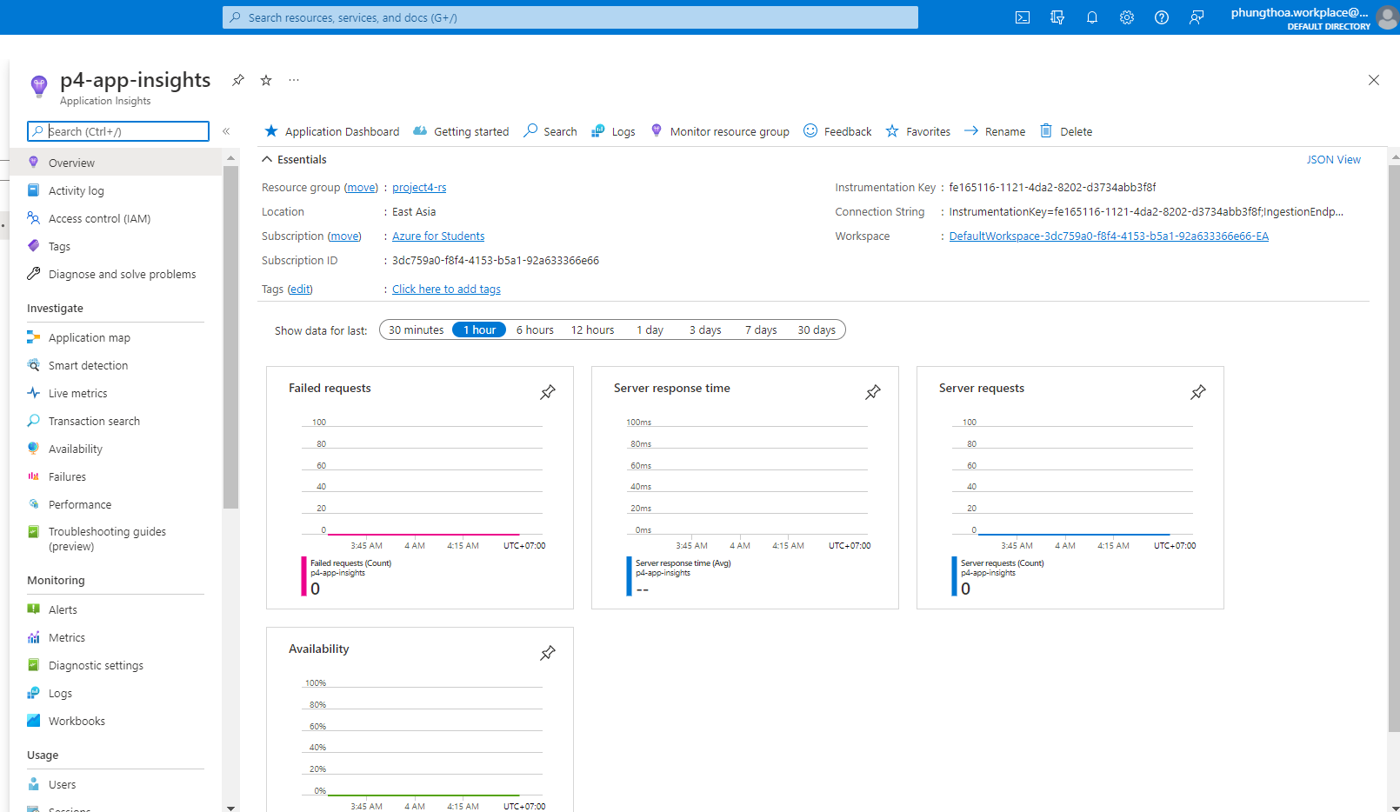

## Azure virtual machine scale sets – VMSS

### Part 1:

CRITERIA

* Enable Application Insights for a VM Scale Set.

MEETS SPECIFICATIONS

* Application Insights monitoring is enabled on the VMSS.
* As evidence, provide a screenshot of the metrics from the VM Scale Set instance. This should show the following information:
  + CPU %
  + Available Memory %
  + Information about the Disk
  + Information about the bytes sent and received.
* There will be 7 graphs that display this data.

HOW TO DO IT

* Enable Application Insights monitoring for the VM Scale Set
* Copy the Instrumentation Key of your Application Insights instance to use in the main.py

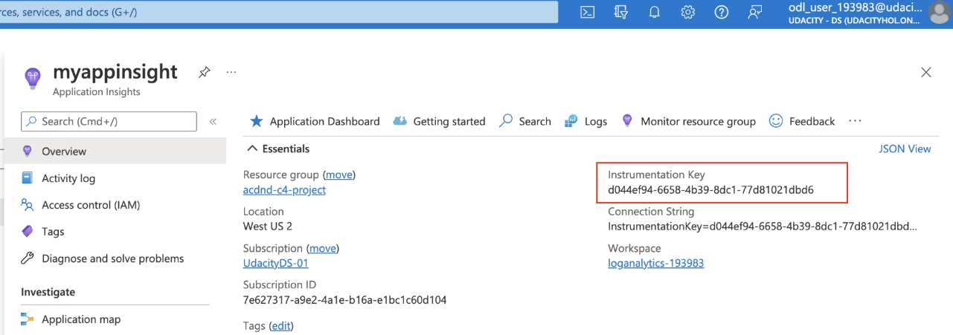  
  
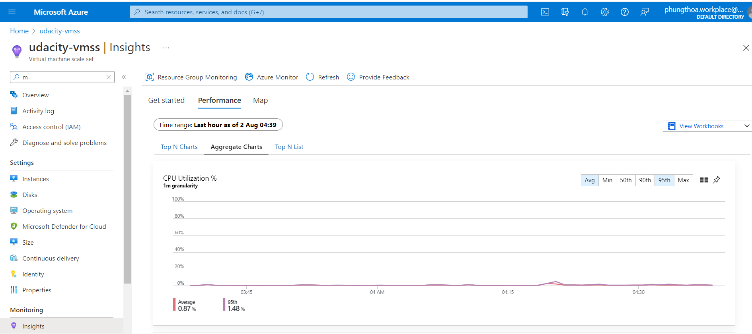  
  
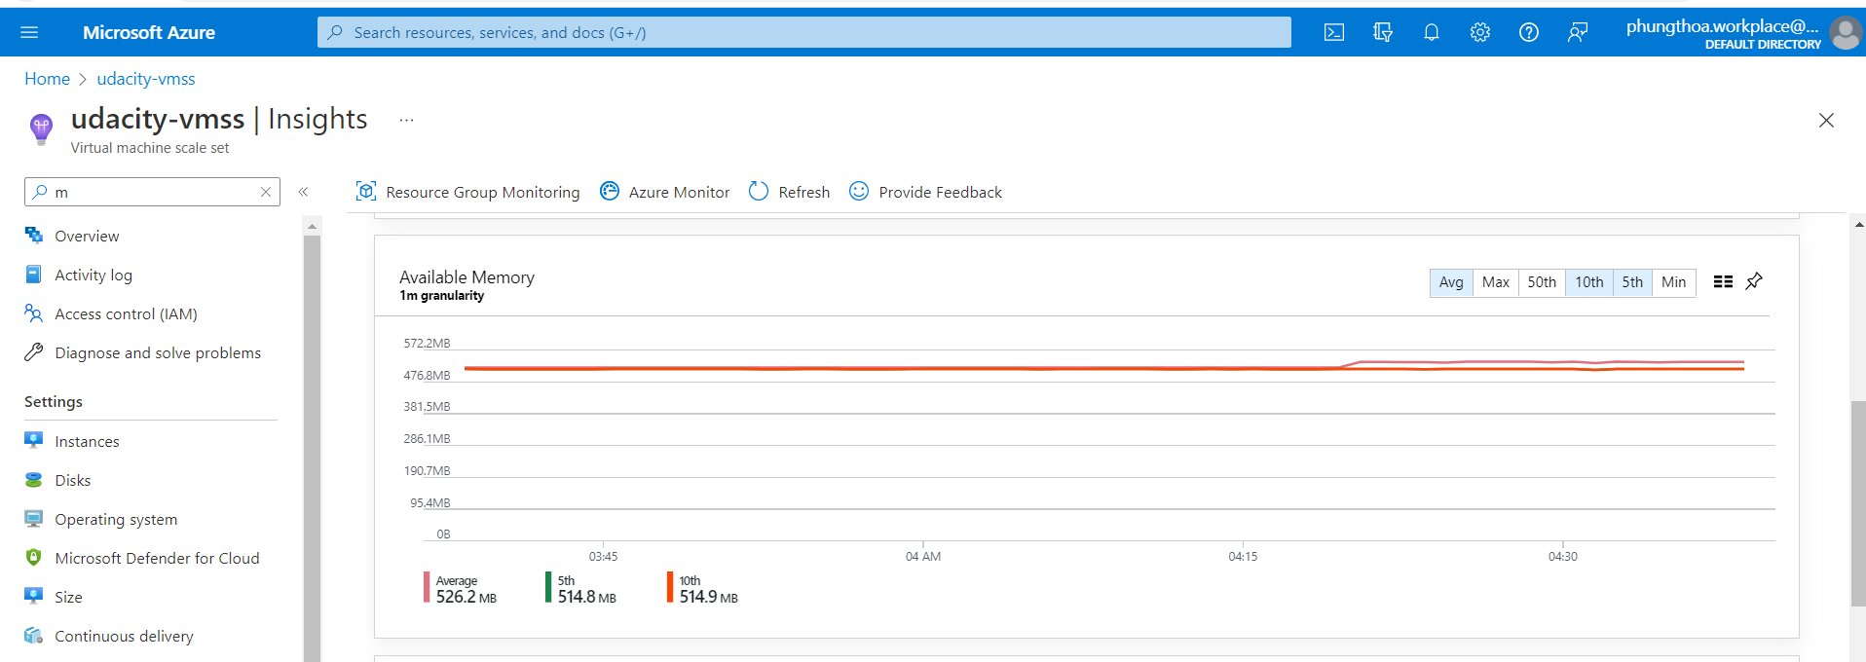  
  
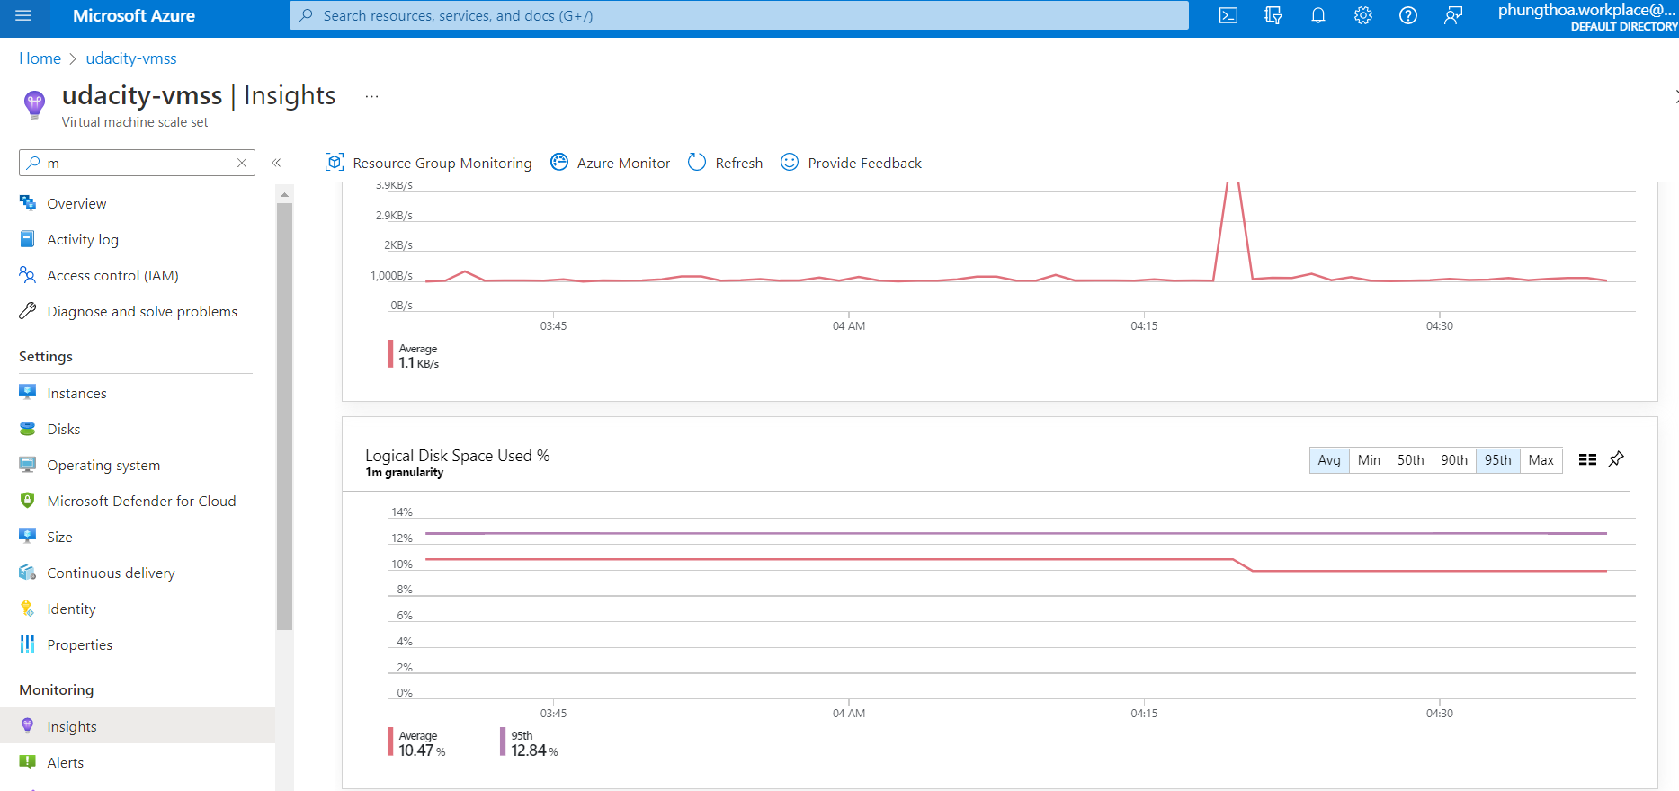  
  
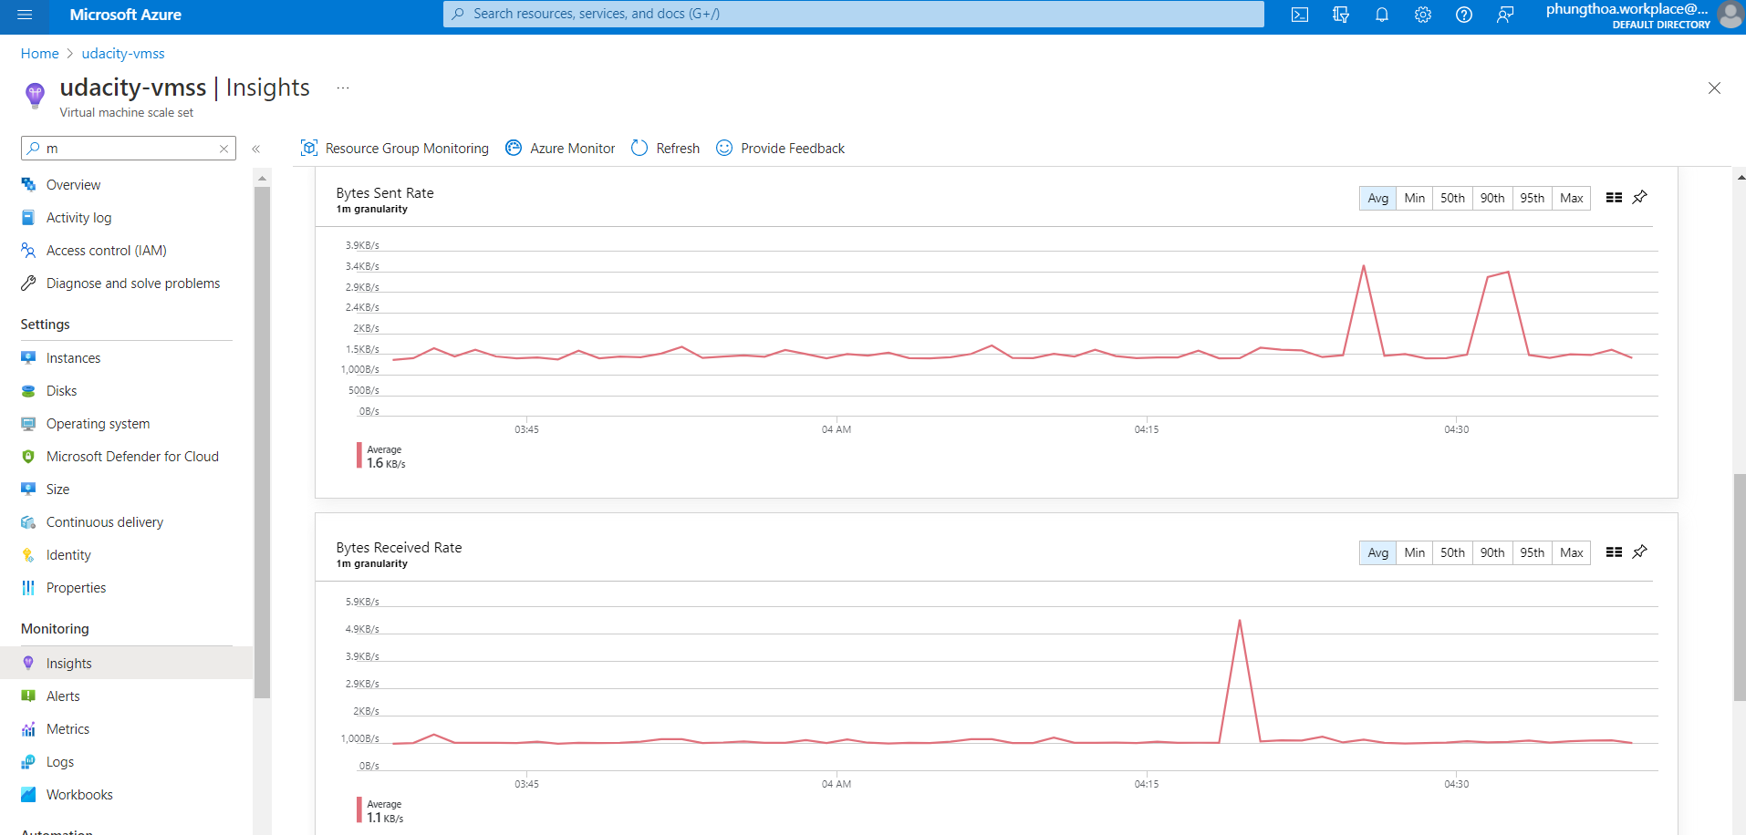

### Part 2:

CRITERIA

* Import and reference the correct libraries to enable the collection of Application Insights telemetry data.

MEETS SPECIFICATIONS

* In the provided main.py of the application:
* Import and reference the correct libraries for Application Insights
* Add code to reference the Application Insights Instrumentation key. The objects that will use this key include:
  + exporter
  + tracer
  + flask middleware
  + logger
* References to each of these objects should be found in the def index() function.

HOW TO DO IT

* Add code to main.py

[Lesson: Collecting Telemetry Data](https://learn.udacity.com/nanodegrees/nd081/parts/cd1885/lessons/532b4a3a-5761-4538-b0e4-e6eb9a614839/concepts/ddd0299f-3543-4dba-ab75-d2f9158eddc3)  
[Set up Azure Monitor for your Python application](https://learn.microsoft.com/en-us/azure/azure-monitor/app/opencensus-python)

* Push code to a new branch Deploy_to_VMSS

### Part 3:

CRITERIA

* View and display the collected data in Azure Application Insights & Azure Log Analytics.

MEETS SPECIFICATIONS

* As evidence, provide screenshots of:
* Application Insight Events that show the results of clicking **vote** for each **Dogs** & **Cats**
* The output of the **traces** query in Azure Log Analytics
* The chart created from the output of the **traces** query

HOW TO DO IT

* Deploy the application to one of the VMSS instances: [Deploy VMSS](https://learn.udacity.com/nanodegrees/nd081/parts/cd1885/lessons/d162f57b-152e-429d-957b-81386d420175/concepts/5531a134-b9af-4155-a750-374a84b2b1c0)

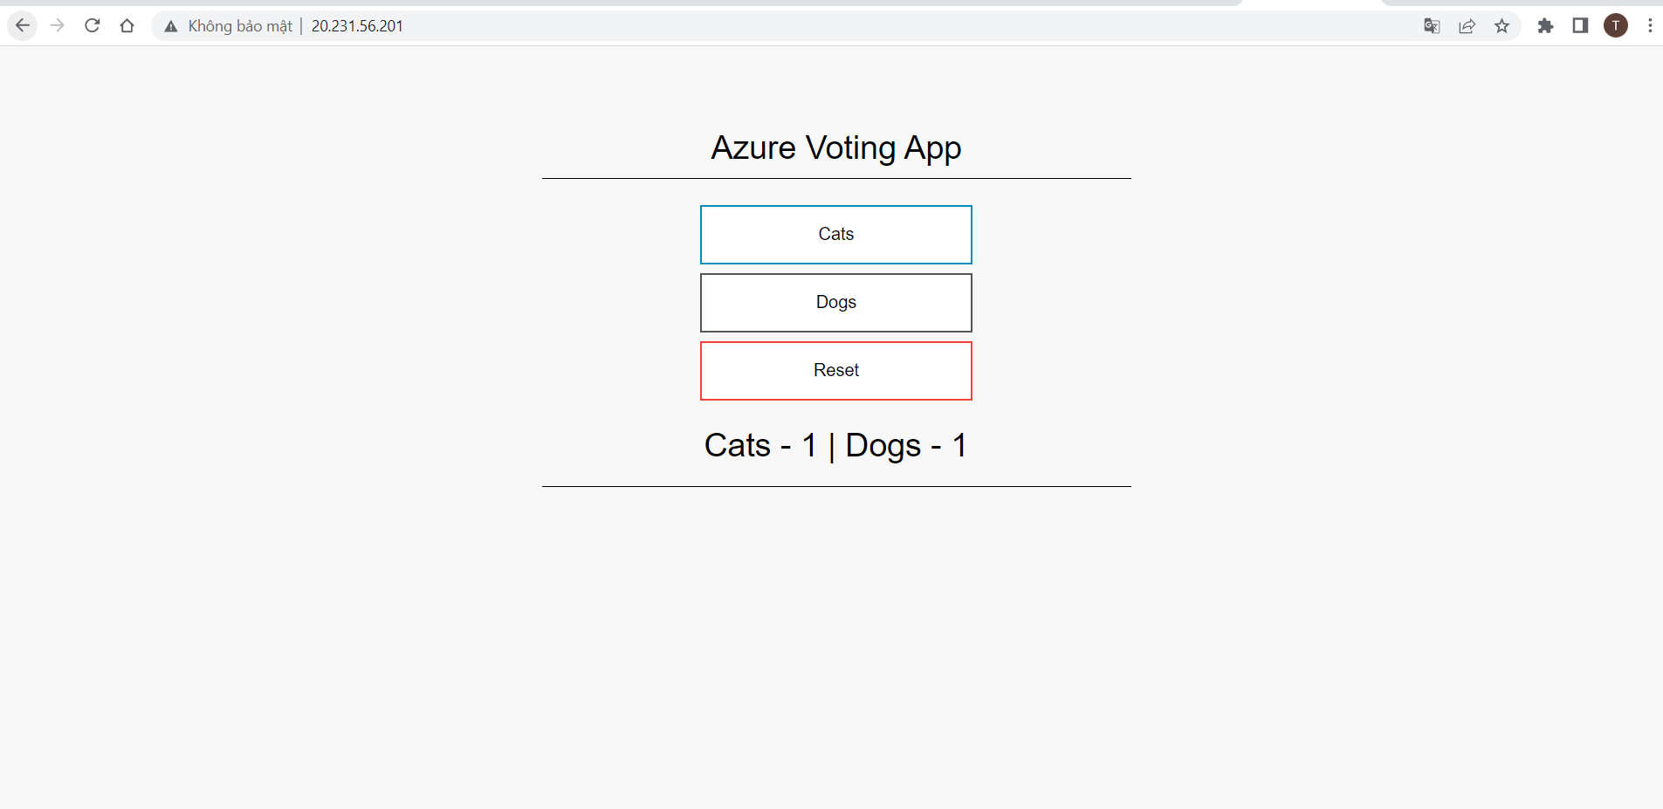  
  
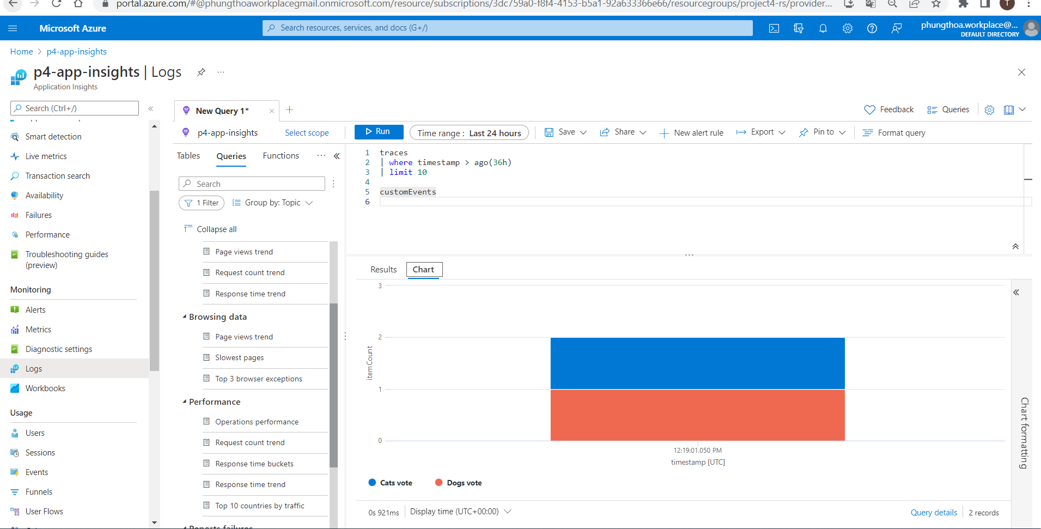  
  
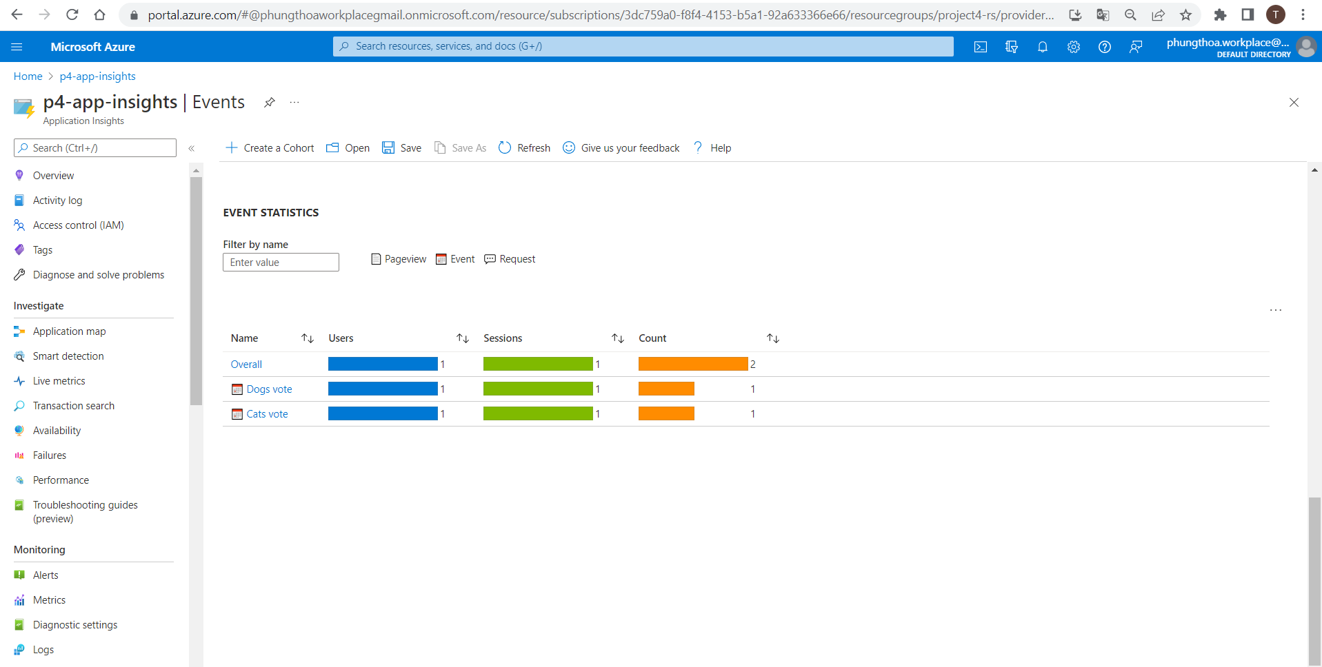

### Part 4:

CRITERIA

* Create an auto scaling rule for a VM Scale Set.

MEETS SPECIFICATIONS

* Create an auto-scaling rule for a VMSS.
* As evidence, provide a screenshot showing the conditions set for the auto scaling rule. This can be found in the **Scaling** item in the VM Scale Set.

### Part 5:

CRITERIA

* Cause the VM Scale Set to auto scale.

MEETS SPECIFICATIONS

* Trigger the VM Scale Set auto scale rule.
* As evidence, provide the following screenshots:
* The Activity log of the VM scale set that shows it scaled up, including a timestamp.
* The new instances being created.
* The metrics showing the load increasing, then decreasing once scaled up, including a timestamp.

HOW TO DO IT

* Tạo Autoscaling VMSS: [Deploy VMSS (Autoscaling VMSS)](https://learn.udacity.com/nanodegrees/nd081/parts/cd1885/lessons/d162f57b-152e-429d-957b-81386d420175/concepts/5531a134-b9af-4155-a750-374a84b2b1c0)

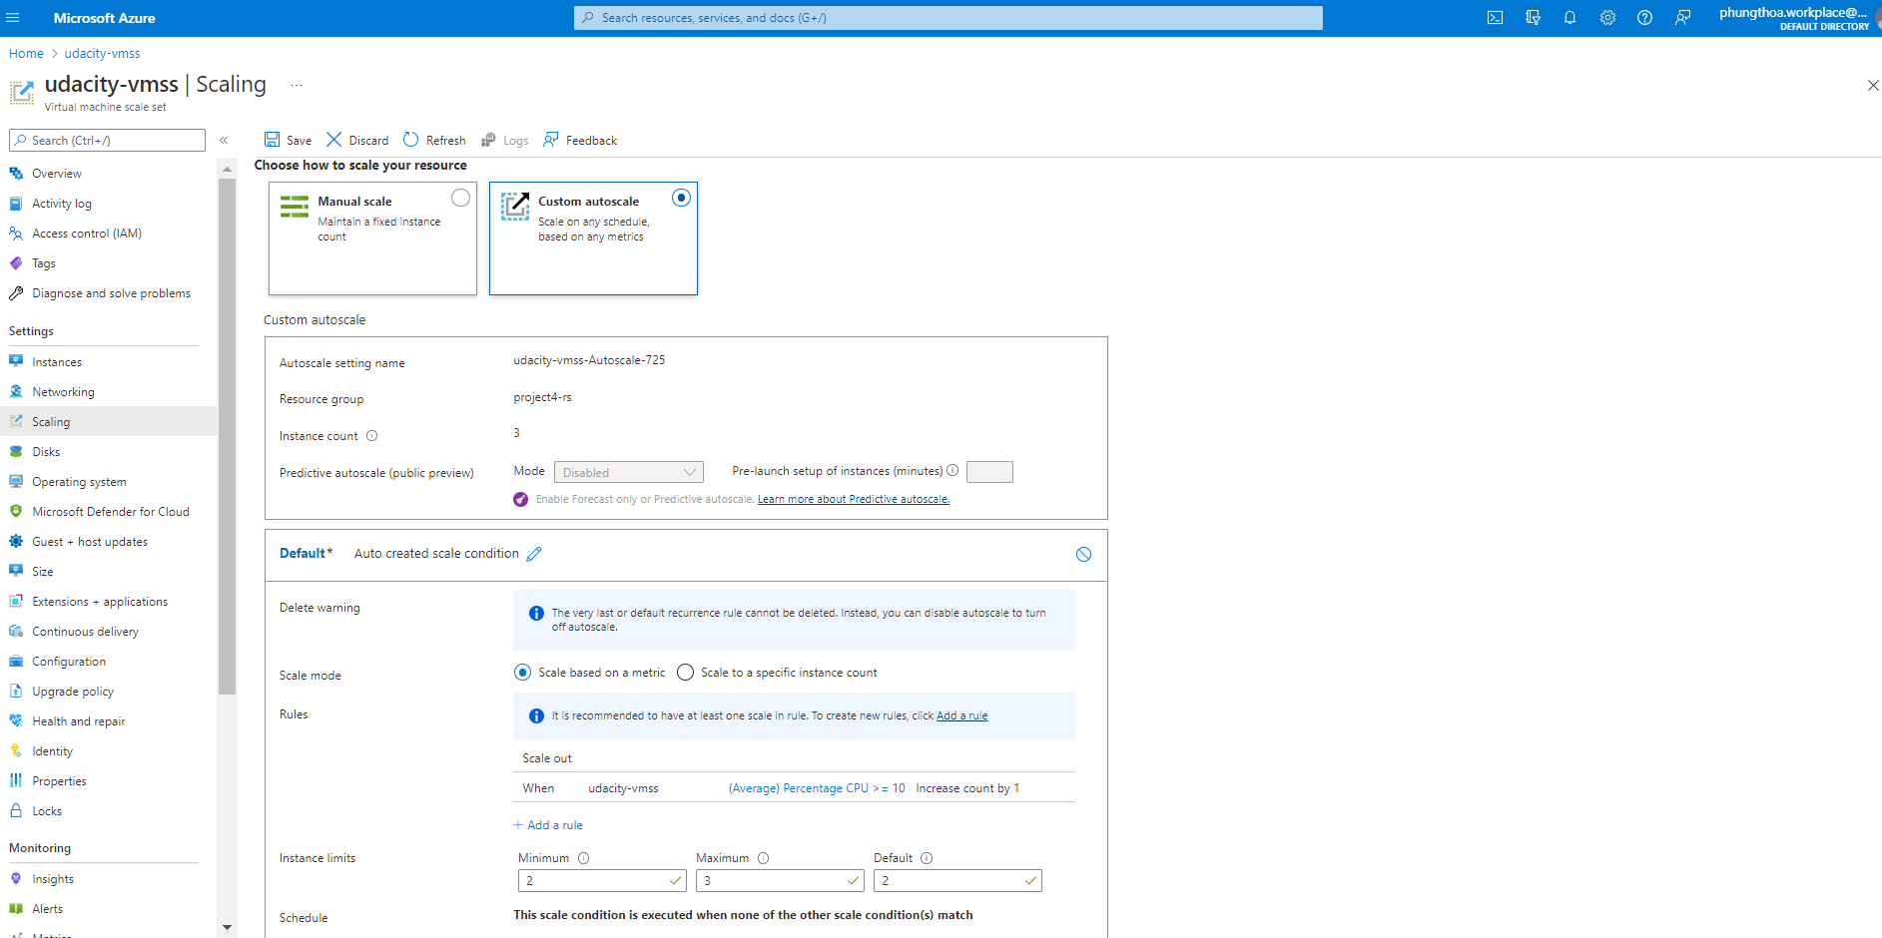  
  
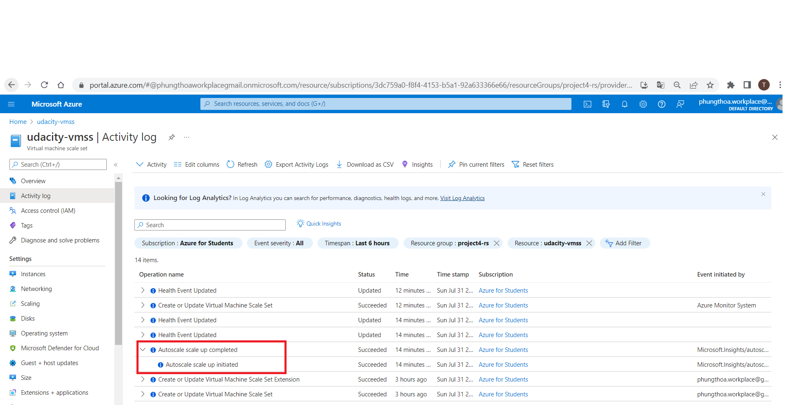  
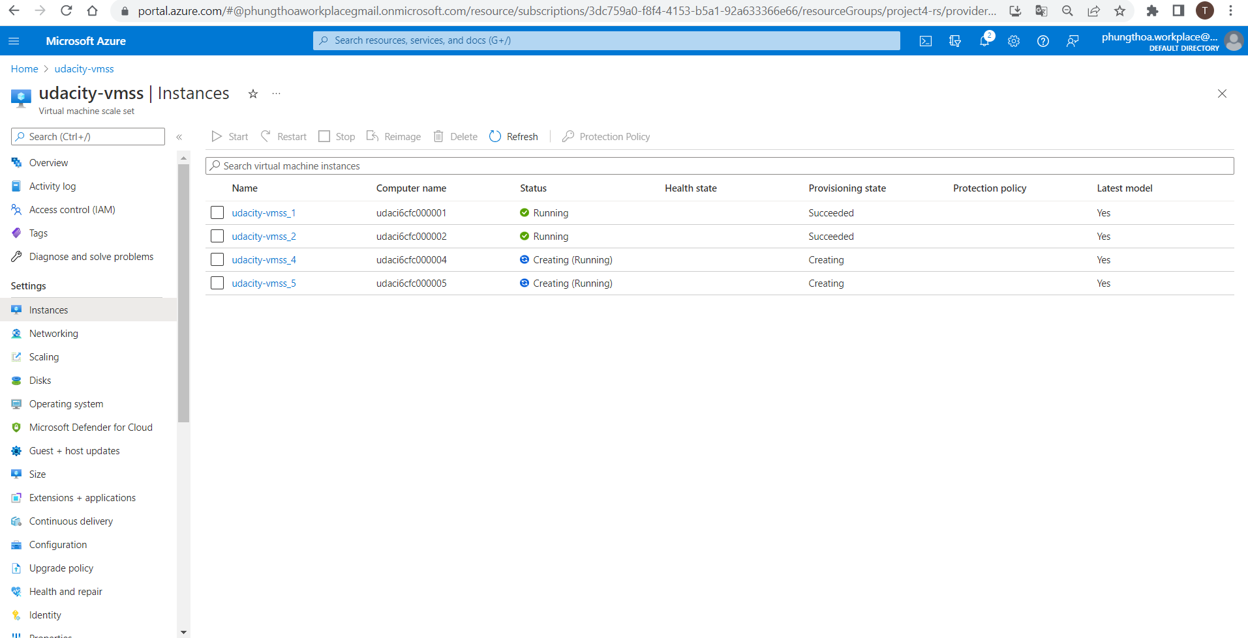  
  
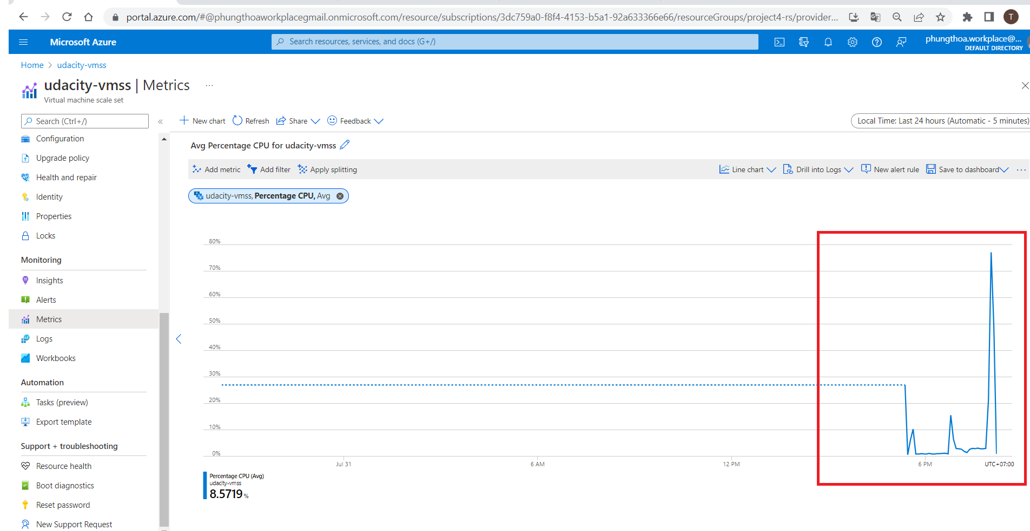

## Azure Kubernetes Service –AKS

### Part 1:

CRITERIA

* Enable Application Insights on an AKS cluster.

MEETS SPECIFICATIONS

* Enable Application Insights on the AKS cluster created from the provided script create-cluster.sh.
* As evidence, provide a screenshot showing Application Insights is enabled on the AKS cluster.

HOW TO DO IT

* [Steps to deploy AKS](https://learn.udacity.com/nanodegrees/nd081/parts/cd1885/lessons/d162f57b-152e-429d-957b-81386d420175/concepts/41691667-506f-4249-adf0-e88617c8639c) (item 1 → 7)

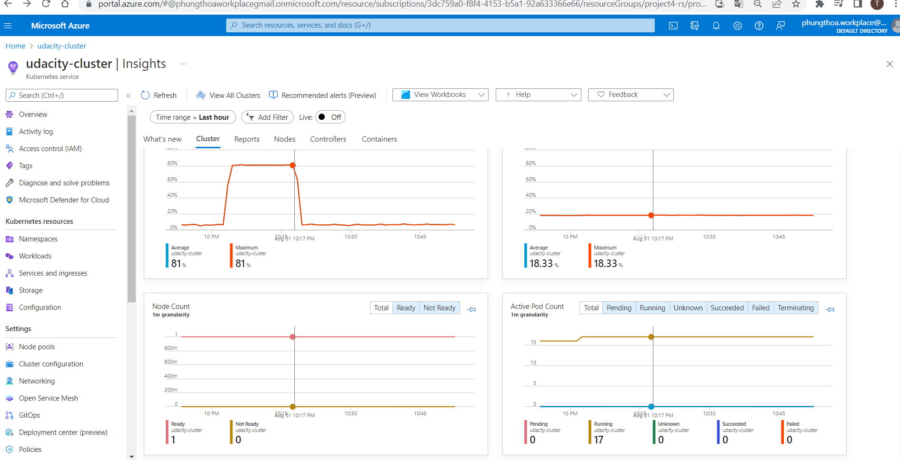

### Part 2:

CRITERIA

* Create an Azure Alert.

MEETS SPECIFICATIONS

* Create an Azure Alert in Azure Monitor. This alert should trigger when the number of pods increases beyond a certain threshold.
* As evidence, provide a screenshot of the Azure Alert and email sent when the alert is triggered.

HOW TO DO IT

* Create an alert in Azure Monitor to trigger: [Lesson: Create Alerts](https://learn.udacity.com/nanodegrees/nd081/parts/cd1885/lessons/000396db-a811-4bca-84c4-9cdbc4871c56/concepts/13b0ef95-c183-43ba-bd03-b9c6abef2d54)

### Part 3:

CRITERIA

* Create a horizontal pod auto scaler and cause load on the container.

MEETS SPECIFICATIONS

* Create a horizontal pod autoscaler and cause load on the container.
* As evidence, provide screenshots showing:
  + The output of the Horizontal Pod Autoscaler, showing an increase in the number of pods.
  + The Application Insights metrics which show the increase in the number of pods.
  + The email you received from the alert when the pod count increased.

HOW TO DO IT

* [Create Autoscaling AKS Cluster](https://learn.udacity.com/nanodegrees/nd081/parts/cd1885/lessons/d162f57b-152e-429d-957b-81386d420175/concepts/41691667-506f-4249-adf0-e88617c8639c)

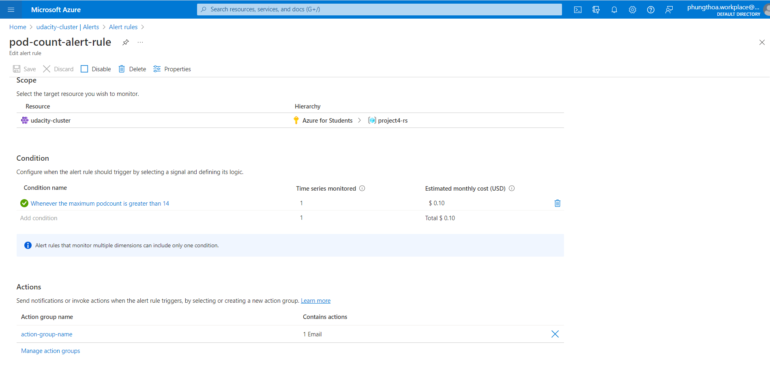  
  
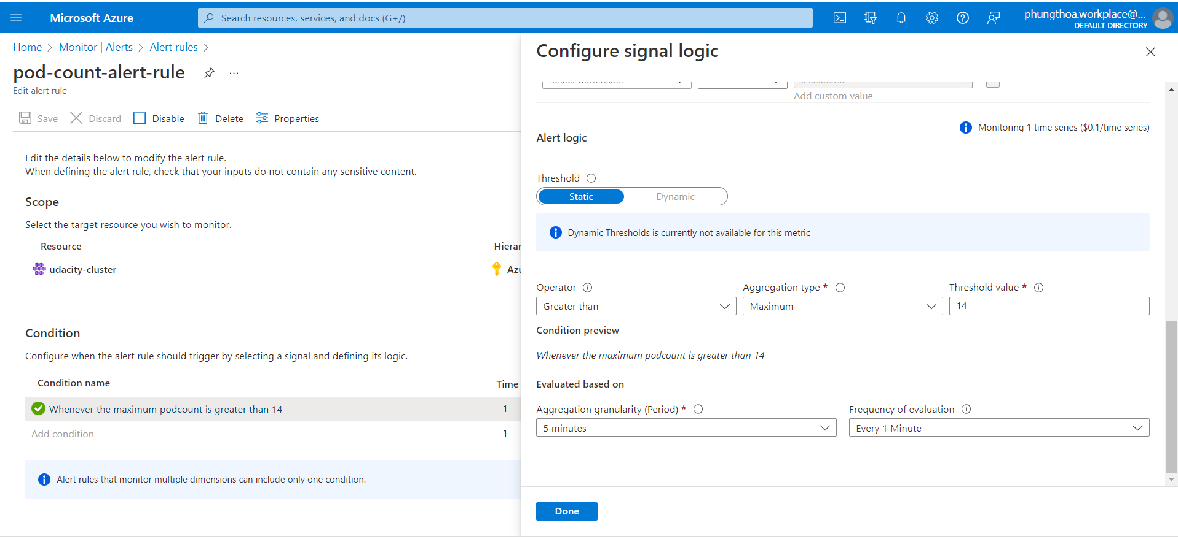  
  
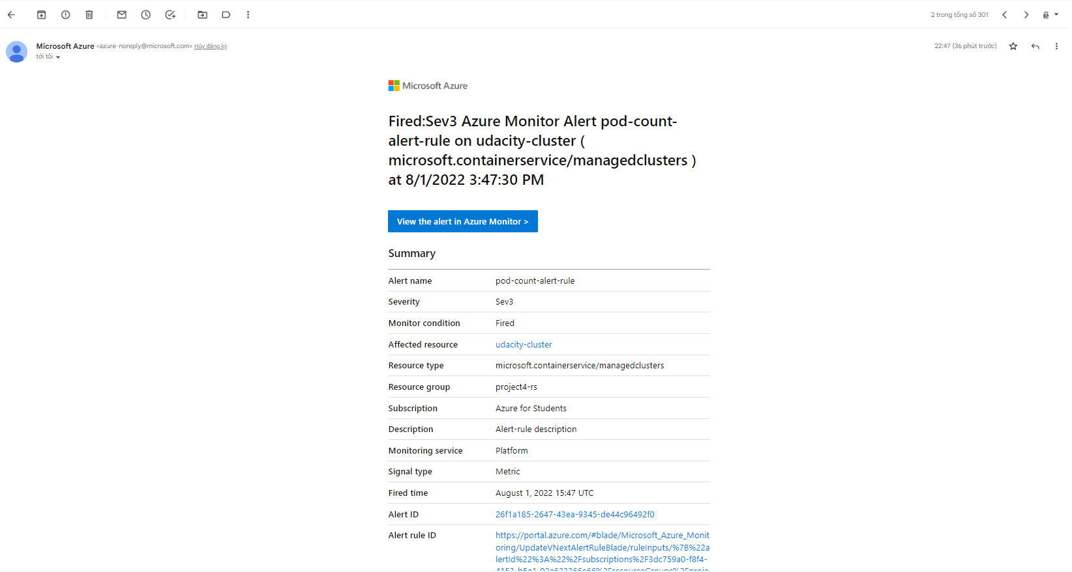  
  
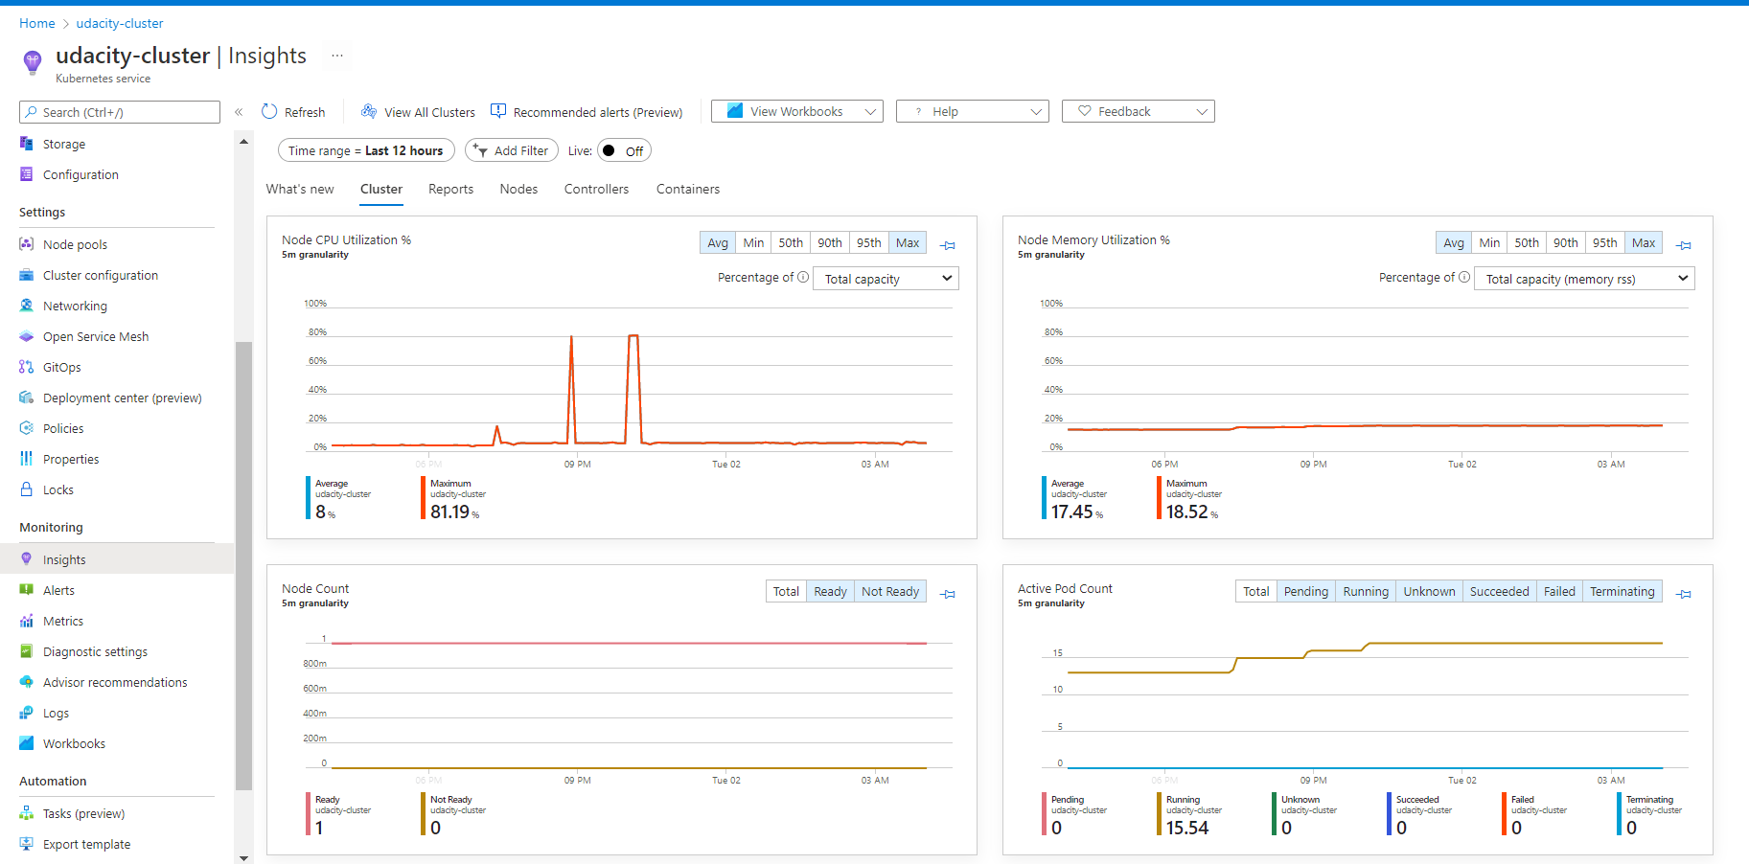  
  
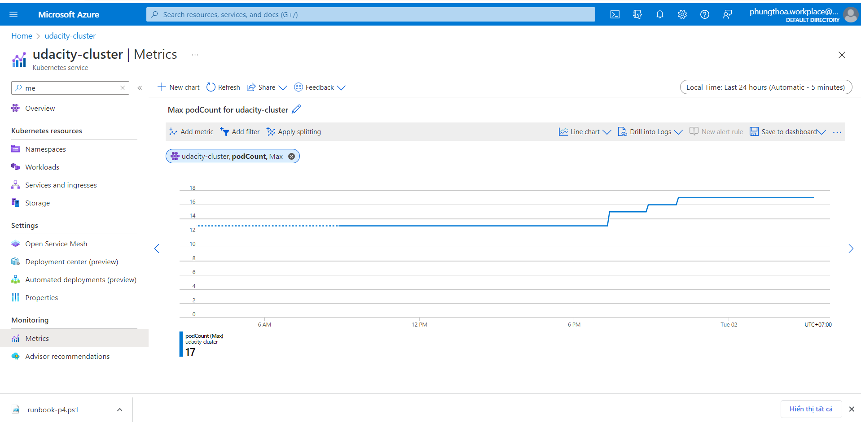  
  
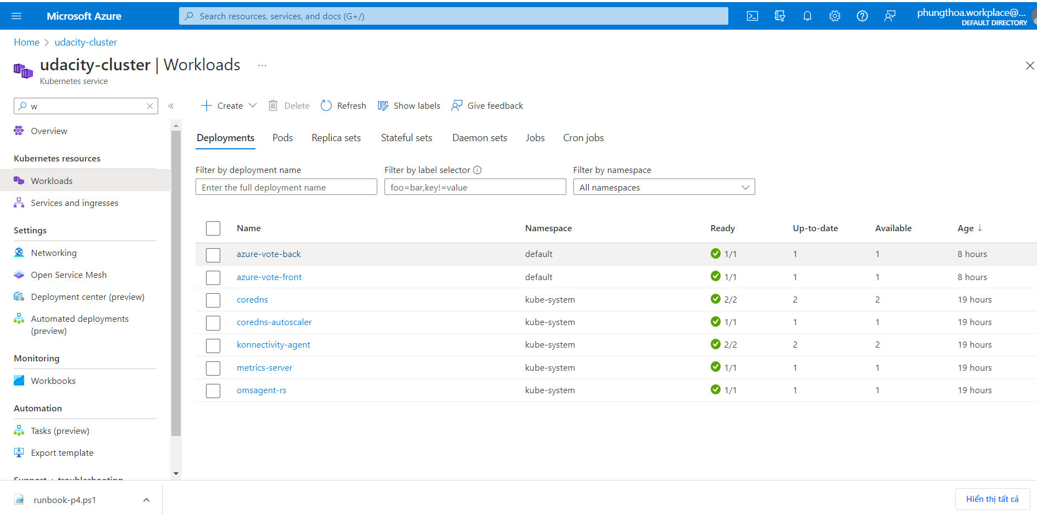

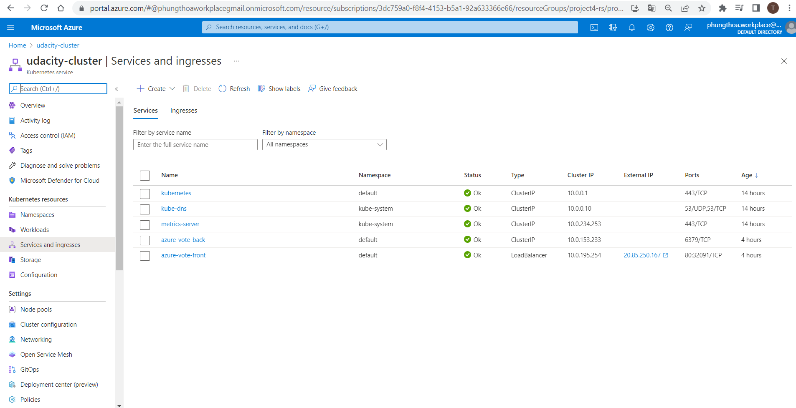

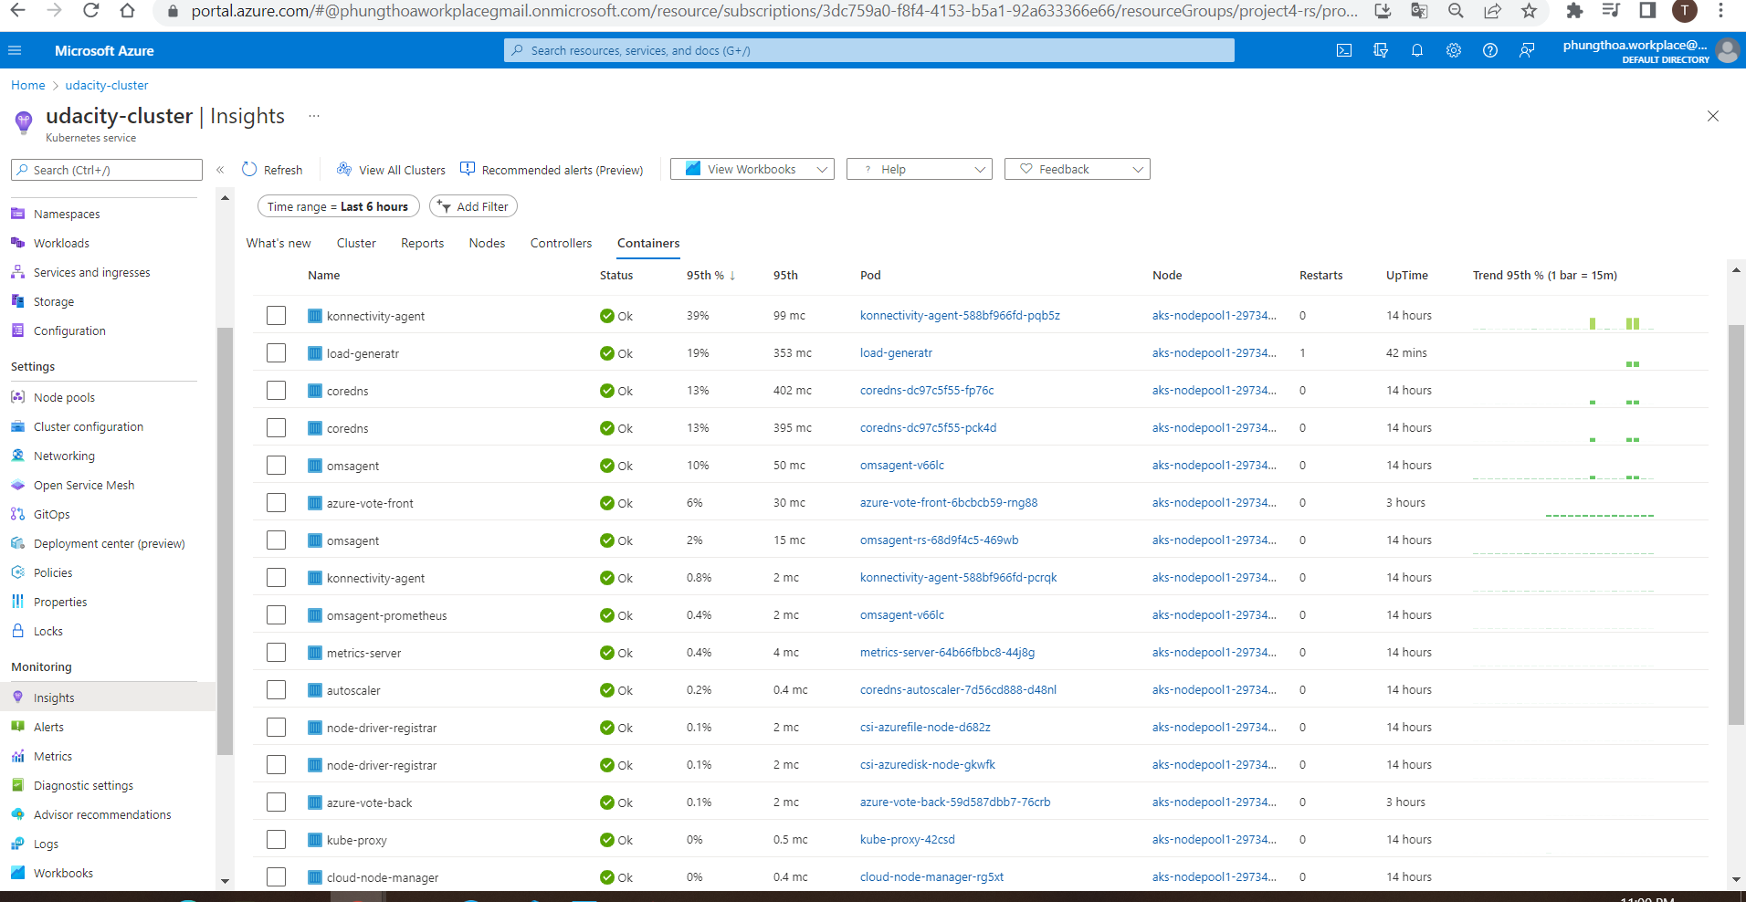

## Automate Resolution of Performance Issues

### Part 1:

CRITERIA

* Create an Azure RunBook to be executed by an Azure Automation Account.

MEETS SPECIFICATIONS

* Azure Automation Account and RunBook resources are created.
* As evidence, provide a screenshot of your resource group containing your running resources.

HOW TO DO IT

* Create runbook: [Lesson: Create a Runbook](https://learn.udacity.com/nanodegrees/nd081/parts/cd1885/lessons/23255c6e-3add-4016-8a0a-abd364efa720/concepts/752b89b3-e61a-471f-b6b5-9ec9c2228d1f)
* Code script for runbook to remedy a problem
* Create an alert rule to trigger runbook

Ex: Stop VMs in a scale set when CPU% >= 5 by Runbook Python

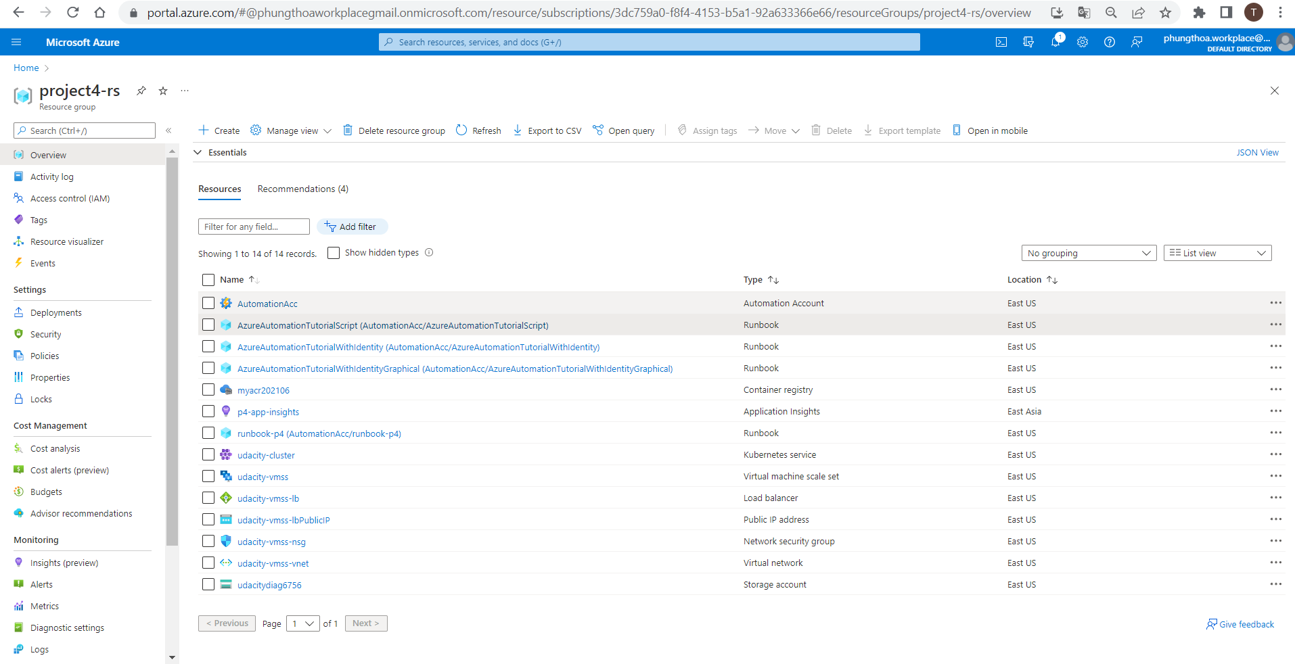

### Part 2:

CRITERIA

* Configure an Azure Alert to trigger the RunBook to execute.

MEETS SPECIFICATIONS

* Configure an Azure Alert in Azure Monitor to trigger the RunBook.
* As evidence, provide a screenshot of the configuration.

HOW TO DO IT

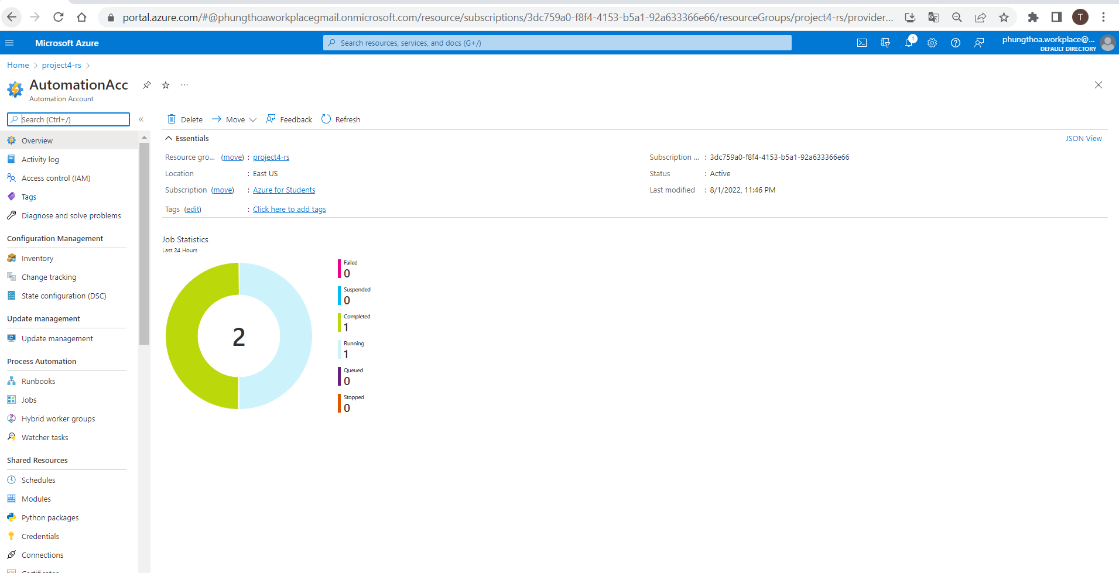  
  
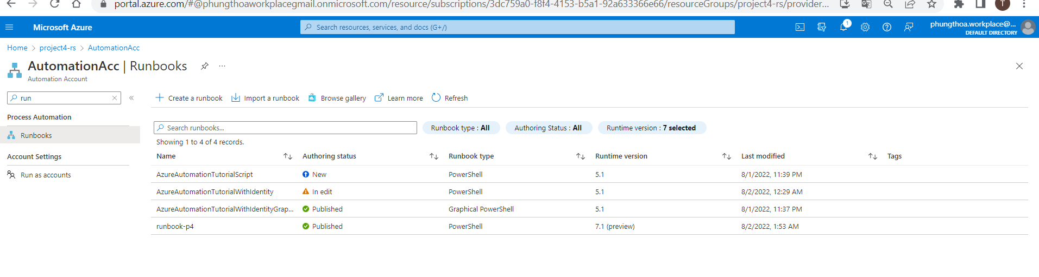  
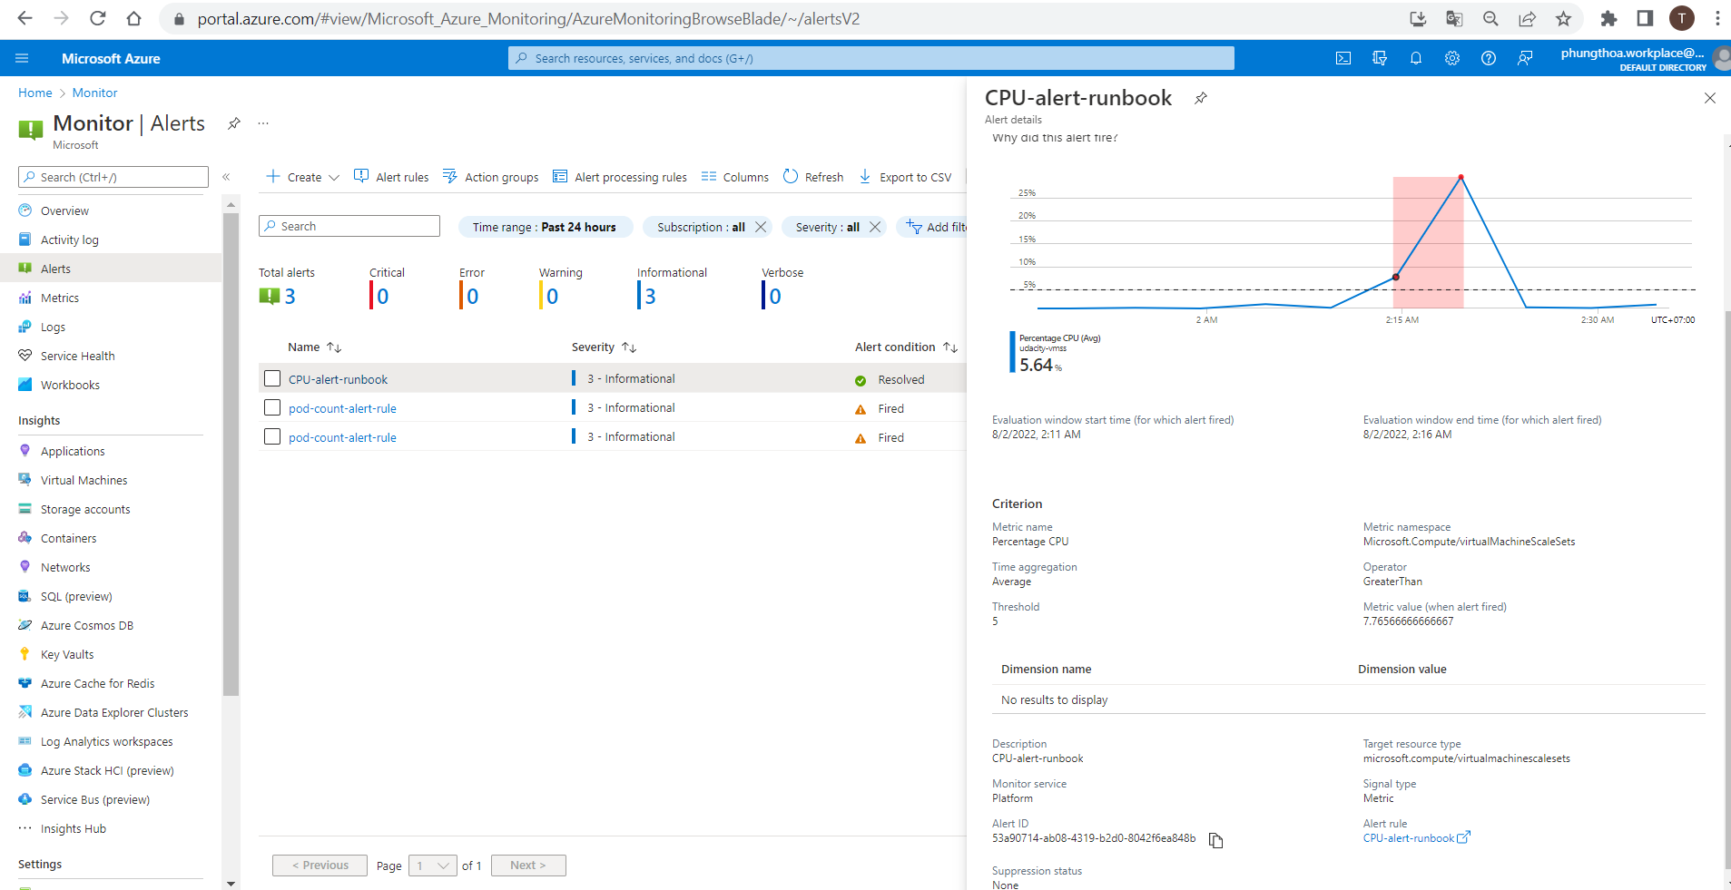

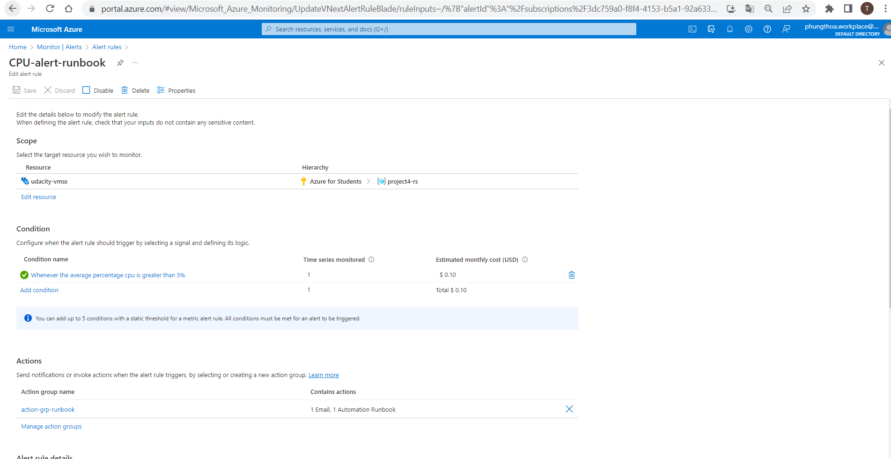

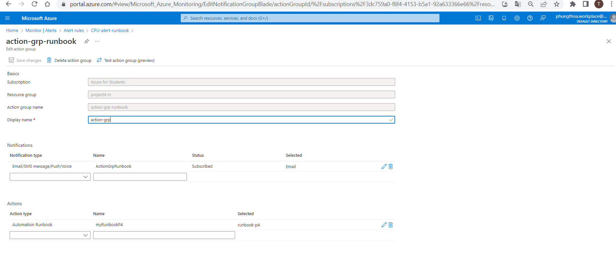

### Part 3:

CRITERIA

* Cause the RunBook to be automatically triggered and resolve a problem.

MEETS SPECIFICATIONS

* Trigger the Azure Alert. The RunBook should execute and resolve the issue.
* As evidence, provide the following screenshots:
  + Email showing the alert was triggered
  + Metrics or other evidence showing the RunBook executed and resolved the issue.

HOW TO DO IT

